**CHAPTER ONE**

**INTRODUCTION**

**1.1 BACKGROUND TO THE STUDY**

A riparian zone is the interface between land and water bodies, including streams, rivers, lakes and estuarine marine shores. Riparian zones can therefore be considered as a transitional belt between terrestrial and aquatic ecosystems and are distinguished by gradients in biophysical conditions, ecological processes and biota (National Research Council, U.S, 2002). Land-use and land-cover along river corridors are by far the most dynamics of all ecosystems in both natural and altered landscapes. The riparian landscapes are made up of patches of distinct vegetation types, wetlands and other land uses, such as agricultural crops and urban settlements. A river’s corridor vegetation plays a significant role in soil erosion, channel stability, wildlife and fish habitat, and water quality (Ahmad and Nobukazu, 2004). Riparian corridors have been recognized as important landscape features that provide unique habitat for many wildlife species as well as filtering capabilities for removing nutrient pollutants from agricultural runoff and urbanized areas before they reach waterways (Goetz, 2006). A riparian zone is often a habitat for rare species and it is also a breeding ground for aquatic fauna such as fish and invertebrates (Naiman *et. al.*, 2005). Loss of riparian vegetation can decrease the amount of suitable habitat for riparian and aquatic fauna such as fish and invertebrates, thereby reducing stream productivity and fish carrying capacity (Karen and Karen, 1998).

Riparian vegetation has many critical functions; it provides resistance to flowing water as well as to runoff during floods. The vegetation provides protective cover which helps to absorb the forces exerted by flowing water (Watson and Basher, 2006). Riparian plant canopies intercept, store and evaporate a portion of precipitation and have an important role in influencing stream temperature and the health of aquatic species (National Research Council, U.S., 2002). Vegetation in riparian areas also have important roles in regulating the upstream-downstream movement of matter and energy by filtering or stopping the movement of sediments, water and nutrients. Specifically, riparian vegetation has an important filtering role for dissolved nitrogen, phosphorous, and toxins moving along the slope discharge ( Apan *et. al.,* 2002).

In many areas, riparian vegetation is spectrally inimitable because of its more persistent greenness when compared to upland areas and other land-cover classes (Woodward *et. al*., 2018). Riparian vegetation acts as habitat corridors for the flow of species, energy, nutrients and promotes regional biological diversity. It is important to note that the riparian vegetation acts as a buffer zone along rivers and lake shores in various ways. It may minimize the effects from river spates, e.g. the water flowing from upstream reaches downstream through absorption, hence causing stability in the water flow.

At local and regional scales, riparian corridors are delineated in numerous ways, as their definition is usually dependent on research approach or agency targets. Generally, they are the transition between terrestrial and freshwater ecosystems and include components of topography, vegetation, and soils. Riparian corridors are dynamic regions with complex heterogenic landscapes formed by frequent disturbances, and therefore, are challenging to delineate and map across large spatial scales. Even fixed buffers along streams have been broadly employed in delineating riparian corridors. The total potential maximum extent of riparian corridors can be captured based on geomorphology, and within this area, temporal fluctuations in riparian corridor vegetation can be evaluated with spectral imagery.

Detection, identification, and monitoring of riparian areas using conventional field sampling and surveying is often infeasible, as these techniques are time-consuming and costly, and many areas are not easily accessible. Spatially extensive and non-invasive remote sensing techniques are therefore often applied due to their synoptic and repetitive nature and ability to be utilized in areas which are not easily accessible. Conventionally stereoscopic interpretation of aerial photography (between 1:5000 to 1:20,000 scale) has been useful due to the high level of detail apparent on the photographs. However, aerial photography can suffer from error and inconsistency due to both interpreter error, and lack of interpretability in areas of shadow from adjacent trees or terrain. In addition, aerial photographic interpretation is time-consuming, particularly if high spatial or temporal detail is required (Johansen *et. al.,* 2007).

One of the most effective techniques in riparian buffer assessment studies is based on using Geographic Information Systems (GIS), because traditional studies generally depends on field-based surveys, which are time intensive and limit the spatial amount of area that can be assessed. As a result, GIS and remote sensing techniques were found to be a convenient way to determine critical areas near water bodies with regards to quality (Emre, 2013)

**1.2 STATEMENT OF PROBLEM**

Riparian areas have rich floral and faunal diversity, with many terrestrial animal species reliant on riparian corridors for the provision of food, water, shelter, and corridors for species migration (Woodward *et. al.,2018*). Riparian areas represent a relatively small percentage of the total land cover of the Nigeria landmass covering about 5,254 km² (FORMECU 1998) and are intensively disturbed, they are often considered to be at-risk due to the effects of urbanization, agriculture, and modified water flow regime. Anthropogenic activities, such as urbanization, agricultural, industrial, transportation and communication, have altered or degraded many riparian environment. Degradation of riparian zones is a result of complex interrelated responses from geomorphic, hydrologic and biotic processes to climate change and natural and anthropogenic disturbances (Chambers and Miller, 2004). The disturbances can alter the hydrological or sediment regime of the river/stream system and produce changes in the physical properties of riparian ecosystems such as stream channel characteristics, and surface and ground water interactions.

Human activities such as agriculture, harvesting of riparian flora and hunting of riparian fauna, grazing and industrial discharges have a great impact on riparian ecosystems. Direct discharge of untreated waste from industries, domestic and urban sources into fresh water bodies contribute to various forms of pollution, eutrophication, suspended solids, sedimentation and pesticide residues leached from soils and agricultural plantations (Odadal *et. al.*, 2003). Human impact such as dams, deforestation and water use practices pose serious threats to water availability to downstream populations (USAID, 2008). Degradation of riparian zones not only affects the riparian area but also the surface and ground water resources, the aquatic fauna and flora, and the terrestrial ecosystem. The riparian zone of the Ona basin in Ibadan has been degraded over time due to the impact of human activities like urbanization, farming, land and vegetation clearing among other.

In view of the foregoing, this study focuses on using GIS Hydrological analysis and remote sensing techniques to identify the major human activity that affect the riparian zone for proper restoration and conservation practice.

**1.3 SIGNIFICANCE OF THE STUDY**

Riparian zones are important natural bio-filters, protecting aquatic environments from excessive sedimentation, polluted surface runoff and erosion. They supply food and shelter for many aquatic animals, and shade which is a vital part of stream temperature regulation. When riparian zones are damaged by construction or agriculture, biological restoration can take place, usually by human intervention on erosion control and re-vegetation (Egbinola *et. al.,* 2016). The rapid population explosion of the third world nations has put the riparian ecosystem under stress of over exploitation and unsustainable use. Biodiversity resources of riparian include vegetation community, which in most cases are hydrophilic. Conserving riparian areas is one of the most effective ways of maintaining high quality aquatic habitats. River bank is a key place for wildlife biome, range and animal fodders sourced. The removal of streamside vegetation, primarily for development purposes, has resulted in degraded water resources and diminished value for human consumption, recreation, and industrial use.

Riparian has been identified as natural control of water movement, waves and tides. Roots of riparian vegetation deflect wave action and hold bank soil together, the vegetal community network of riparian is a reliable mechanism in natural flood management, and this feature is unique in disaster management. Furthermore, riparian habitat follows the river course, serving as corridor, connecting two or more habitats that may otherwise be isolated by land transformation of areas in between. The focus of this study to evaluate the impact of human activities on the riparian zone of Ona drainage basin in Ibadan, this will help in making informed decisions in planning and management of riparian areas e.g. for re-vegetation of degraded areas, retention of vegetation, stream bank stabilization, and stock management.

Over the years different researches have been carried out in a bid to assess the depletion of the riparian ecosystems in Nigeria, However little has been done on how remote sensing and GIS can help to determine the spatial and temporal changes in riparian zone vegetation. This study on completion will reveal the level of degradation and encroachment on riparian corridor of the Ona drainage basin in Ibadan, the outcome will go a long way in assisting the government, resource managers, planners and decision makers to make inform decisions on the land use activities that might eventually cause flooding.

**1.4 RESEARCH QUESTIONS**

1. What changes have been observed in the riparian zone of the Ona drainage Basin in Ibadan metropolis as determined by the use of satellite imageries, GIS and Hydrological analysis?
2. To what extent has urban land use encroached into the riparian zone of the Ona drainage Basin?
3. What are the suitable management practices for the restoration and management of the Ona drainage Basin’s riparian zone?

**1.5 AIM AND OBJECTIVES**

The aim of this study is to evaluate the impact of human activities on the riparian zone of Ona drainage basin in Ibadan.

The following specific objectives will be pursued in order to achieve the aim stated above: To

1. Estimate the riparian zone with the aid of slope and stream order.
2. Examine the land cover of the riparian zone.
3. Analyze spatial and temporal changes in landscape of the riparian zone
4. Determine the contribution of specific human activities to the changes within the riparian zone.

**1.6 STUDY AREA DESCRIPTION**

**1.6.1 Location**

Ibadan, one of the oldest cities in Africa, is the capital of Oyo State, Nigeria, and has eleven local government areas (LGAs). Ibadan is located in southwestern Nigeria in the southeastern part of Oyo State at about 119 kilometers, northeast of Lagos and 120 kilometers east of the Nigerian international border with the Republic of Benin. It lies completely within the tropical forest zone but close to the boundary between the forest and the derived savanna. This study was carried out on the Ona River which is one of the major Rivers in Ibadan. Geographically, extends between longitudes 3º 52’E and 4º 12’E of the Greenwich and between latitudes 7º 17’N and 7º 25’N of the Equator. Ona River has a length of 55km² an area of 81.0km² and it flows through the low density western part of Ibadan. The river flows in a north-south direction from its source at Akinyele Local Government Area) around Ibese and flows through Eleyele (Ido Local Government Area) where it is dammed and also flows through Apata Ganga (Ibadan south-west Local Government Area) to Oluyole Local Government Area and flows down south all to the Atlantic ocean on Lagos State.

**1.6.2 Geology**

The study area is underlain by basement complex rocks of metamorphic origin of the Pre-Cambrian age. These rocks can be grouped into major and minor rock types. The major types are quartzite of the meta-sedimentary series and the migmatite complex comprising banded gneiss, augen gneiss and magnetite, where the minor rock types include pegmatite, quartz, aplite, diorites, amphibolites and xenoliths (Amanambu, 2016)

**1.6.3 Climate**

Ibadan has a tropical wet and dry climate (köppen climate classification *Aw*), with a lengthy wet season and relatively constant temperatures throughout the course of the year. Ibadan’s wet season runs from March through October, though August sees somewhat of a lull in precipitation. This lull nearly divides the wet season into different wet seasons. November to February forms the city’s dry season, during which Ibadan experiences the typical West African harmattan. The mean total rainfall for Ibadan is 1420.06mm, falling in approximately 109days. There are two peaks for rainfall, June and September. The mean maximum temperature is 26.46ºC, minimum 21.42ºC and the relative humidity is 74.55%. Recent global climate change, however has caused significant variation in these values.

**1.6.4 Relief and Drainage**

Three major landforms which are hills, plains and river valleys dominate the whole landscape of Ibadan region. Two main types of hills are recognized such as the quartzite ridge and gneissic inselbergs, of these the quartzite ridge are by far the most impressive, widespread and the best known within the region. The plains form the most extensive landform system in the area. The general elevation is between 180m and 210m above sea level. The city of Ibadan is naturally drained by four rivers with many tributaries, Ona River in the North and West, Ogbere River towards the East, Ogunpa River flowing through the city and Kudeti River in the Central part of the metropolis. Ogunpa River, a third-order stream with a channel length of 12.76 km and a catchment area of 54.92 km2. Lake Eleyele is located at the northwestern part of the city, while the Osun River and the Asejire Lake bounds the city to the east. The general layout in the area conforms to the dendritic pattern, showing irregular branching in all directions with tributaries joining at all possible angles. The drainage morphology of Ibadan can be described as consisting of three river basins systems, River Ona in the western part of the region, river Ogunpa in the centre and river Kudeti (Egbinola *et. al.,* 2016).

**1.6.5 Vegetation/Land Use**

Until 1970, Ibadan was the largest city in the sub-Saharan Africa (Areola O, 1994). In 1952, it was estimated that the total area of the city was approximately 103.8 km², however, only 36 km² was built up (Egunjobi 1986). This meant that the remaining 67 km² were devoted to non-urban uses, such as farmland, river floodplains, forest reserves and water bodies. These “non-urban land use” disappeared in the 1960s: an aerial photograph in 1973 revealed that the urban landscape had completely spread over about 100km² (Egunjobi, 1986). The land area increased from 136 km² in 1981 to 210-240 km² in 1988-89 (Areola 1994: 101). By the year 2000, it was estimated that Ibadan covered 400 km² (Onibokun, P. and Faniran A. 1995). The growth of the built up area during the second half of the 20th century (from 40km² in the 1950s to 250 km² in the 1990s) shows clearly that there has been an underestimate of the total growth of the city.

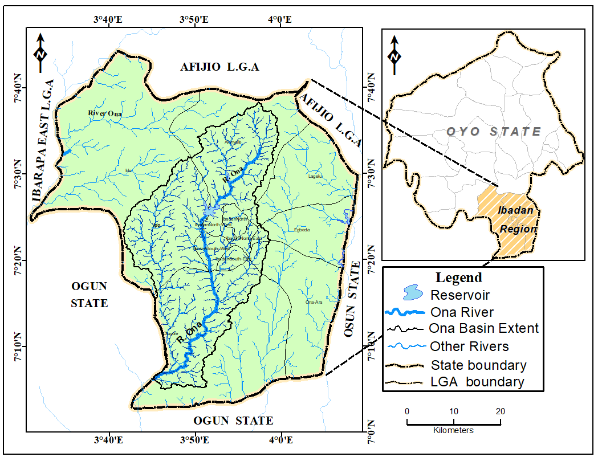

**Fig 1.1. The Study Area**

**SOURCE: Modified from Administrative Map of Oyo State and author’s analysis 2019.**

**CHAPTER TWO**

**2.0 CONCEPTUAL FRAMEWORK AND LITERATURE REVIEW**

**2.1 Conceptual Framework**

This section addresses the ecosystem concept and benefit of riparian zone as a vital part the river’s ecosystem.

**2.1.1 Ecosystem Concept of Riparian Zones**

This concept present an ecosystem perspective of riparian zones that focuses on the ecological linkages between terrestrial and aquatic ecosystems within the context of fluvial landforms and the geomorphic processes that create them, boundaries of riparian zones extend outward to the limits of flooding and upward into the canopy of streamside vegetation. Dimensions of the zone of influence for a specific ecological process are determined by its unique spatial patterns and temporal dynamics. Extending this concept in time and space, riparian zones can be viewed in terms of the spatial and temporal patterns of hydrologic and geomorphic processes, terrestrial plant succession and aquatic ecosystems, this ecosystem model is based on the premise that geomorphic processes create a mosaic of stream channels and floodplains within the valley floor. Geomorphic and other disturbance processes of both upland and fluvial origin affect riparian zones, determining the spatial pattern and successional development of riparian vegetation. Valley floor landforms and associated riparian vegetation form the array of physical habitats within the active channels and floodplains, and the streamside plant communities are major determinants of the abundance and quality of nutritional resources for stream ecosystems.

Past researches on relations among geomorphic surfaces, vegetation, and channel hydraulics concentrated in lowland, floodplain rivers where lateral channel migration is a dominant process of valley floor landform development in steeper montane landscapes, valley floor landforms are sculpted by fluvial processes and a variety of mass soil movement processes from tributaries and adjacent hill slopes. Geomorphic processes that modify riparian zones operate on time scales ranging from chronic (months to years) to episodic (decades to centuries) and on spatial scales ranging from localized shifts in channel position involving a few square meters to basin-wide flooding. In addition to fluvial or erosional events that create new geomorphic surfaces, sediment deposition and battering during floods cause less severe but more frequent damage, which may influence the course and rate of vegetation succession (Gregory *et. al.,* 1991).

**2.1.2 The Riparian Zone**

Riparian zones are the Interfaces between terrestrial and aquatic ecosystems. As ecotones, they encompass sharp gradients of environmental factors, ecological processes, and plant communities. Riparian zones are not easily delineated but are comprised of mosaics of land- forms, communities, and environments within the larger landscape. The ecosystem perspective of riparian zones is a conceptual model of riparian zones that integrates the physical processes that shape valley floor landscapes, the succession of terrestrial plant communities on these geomorphic surfaces, the formation of habitat, and the production of nutritional resources for aquatic ecosystems. Most riparian classification systems focus on a few selected attributes of riparian areas, such as hydric soil or hydrophilic plant associations. Although these perspectives adequately characterize terrestrial plant communities, they provide little understanding of the wide array of ecological processes and communities associated with the land-water interface, and they encourage an inappropriately rigid delineation of riparian boundaries. The ecotonal nature of riverine boundaries has served as a framework for understanding the organization, diversity and stability of aquatic communities in fluvial ecosystems.

**2.1.2.1 Benefits of vegetated riparian corridor**

In order to fully reap the benefits of riparian corridors, it is essential to retain corridors in a vegetated state, preferably as forests. When lands are not forested, management efforts should be undertaken to assist the growth of vegetation and the re-establishment of forests. As discussed in the following sections, the benefits of vegetated riparian corridors relate to how the corridors function to protect air, land, water quality, and animal habitat. While the benefits of riparian corridors have been grouped into several broad categories, many interrelationships exist between them.

1. **Natural Floodplains:** Vegetated riparian corridors with undeveloped floodplains slow the concentration of runoff and flood flows, reducing the height and velocity of floodwaters downstream. As part of a municipality’s flood zone management strategy, riparian corridors set development back from the banks of waterways and out of most floodways. Lastly, the riparian corridor serves as a natural reservoir by storing runoff and then releasing it over time into the stream, helping to maintain base flow.
2. **Control of Erosion:** Riparian corridors can significantly reduce erosion of stream banks and adjoining floodplain, helping to prevent sedimentation of the stream. The riparian corridor reduces the velocity of runoff, allowing much of the sediment and attached phosphorus (roughly 85 percent of available phosphorus is bound to sediment) to be filtered out before reaching the stream. Also, the floor of a vegetated buffer acts as a natural sponge, due to the large soil pore spaces created by the root system of the trees and plants. This allows increased infiltration around the stream, helping to maintain stream base flow, and enables the phosphorus to be utilized and transformed by the corridor’s vegetation. The root system of trees within the riparian corridor also helps to hold the surrounding soil in place during storms, and minimizes the slumping of stream banks over time. This is important for maintaining the width and overall health of a stream since the surface area of the stream bottom is where most biological activity occurs. Sedimentation of a stream can also increase potential for flooding, since the size and carrying capacity of the stream channel are reduced. In addition, eroded soil entering the stream is initially suspended in the water, decreasing the amount of sunlight reaching aquatic plants, inhibiting their growth and reproduction. Suspended sediment also harms a stream’s fish life by clogging fish gills, reducing water circulation and aeration of the blood.
3. **Water Quality/Stream Health:** There are several ways the riparian corridor enhances water quality. As mentioned earlier, the vegetated corridor operates as a filter to reduce the flow of sediment and phosphorus into streams. The reduction of phosphorus is especially important to water quality: phosphorus is typically the nutrient that controls the growth and activity of aquatic organisms in freshwater. Excessive phosphorus loading on the stream leads to proliferation of algae and other aquatic plants and is often referred to as eutrophication. ***Eutrophication*** adversely affects water quality, particularly in the smaller slow-moving streams, when algal blooms and other aquatic plant growth interfere with the amount of sunlight reaching submerged aquatic plants. The lack or absence of sunlight impedes photosynthesis in the submerged aquatic plants, causing them to die. Since the bacteria that decompose the dying plants maintain a high oxygen demand, the dissolved oxygen levels in the stream drop abruptly, causing fish and other aquatic life to die. Another factor affecting the amount of dissolved oxygen in a stream is water temperature. Cold water is able to hold more dissolved oxygen. Therefore, increases in water temperature are a form of thermal pollution due to the direct effect on aquatic life. Shading of the stream by a forested riparian corridor will help to keep the stream cool, increasing the potential level of dissolved oxygen and lowering stress on fish (especially trout) and aquatic macro invertebrates. Riparian corridors also reduce the amount of nitrogen entering the stream directly or via shallow groundwater flow. Nitrogen applied to farmland or lawns as fertilizer or found in animal waste is water-soluble and transforms to nitrate in runoff. Since nitrate does not attach to soil particles (as phosphorus does), it can leach into groundwater and streams. Excessive nitrates in a stream can also contribute to eutrophication. As a contaminant nitrates can increase water treatment costs. A riparian corridor will impede and intercept runoff from rain events and shallow groundwater flow. Once the runoff or shallow groundwater flow enters the riparian corridor, the nitrates are transformed by bacteria in the soil for consumption by the corridor’s vegetation. Finally, the trees and plants that constitute the riparian corridor also contribute to the health of the stream by providing food to aquatic organisms. The organic debris deposited from streamside vegetation is a food source that supports various forms of algae (i.e. diatoms) that are preferred by fish and other plant eating stream organisms. As leaves accumulate on the surface, they form leaf packs that provide habitat for small stream organisms that are food for larger organisms. Recent studies by the Stroud Water Research Center and the University of Idaho have found that loss of headwater streams can adversely affect downstream conditions. The small, first and second order streams appear to be conduits for organic material to enter the stream system. The insects and other organisms that are dominant in these streams begin the nutrient cycles that support downstream organisms. When first and second order streams are culverted or otherwise lost through development, much less organic material enters the stream, and downstream populations of fish suffer. This underscores the importance of protecting the small streams in the headwaters area of the watershed.
4. **Habitat Protection** The disappearance of habitat for a variety of species is one of the problems caused by suburban development. Riparian corridors, and greenways in general, offer wide swaths of land, allowing various animals to move more safely among developed portions of a municipality and between larger open space habitats (i.e., parks and land preserves). In addition, the riparian corridor serves as a critical interface for many animal species that live and breed along streams. Plants also have specific needs that are dependent upon the larger areas of natural surroundings often found along streams. For example, various spring ephemeral flowers and understory shrubs depend upon shade and filtered light caused by larger trees within forested riparian corridors. To meet these needs, forested areas must be wide enough to contain a broad tree canopy that fully shades the ground. Also, when riparian corridors are forested they add variety to the in stream habitat of the waterway via the shedding of large stable debris from adjacent trees. This debris tends to accumulate, forming small dams, which beneficially affects the depth, flow, and texture of the stream. This debris also increases the physical surface area of the stream, which helps to support aquatic life. Finally, the natural dams help the stream channel resist degradation and down cutting by retaining organic matter and inorganic sediments. The streamside forest is home to a variety of mammals, birds, amphibians and reptiles. The forested edge between land and water is prime habitat; berries, buds, fruits and nuts offer a varied menu and there are plentiful places for nesting. The riparian corridor offers a continuous transportation corridor for the migration of plant (via seeds) and animal species.
5. **Climate Moderation:** The trees within forested riparian corridors add moisture to the air and create shade, significantly reducing air temperatures in the summer. This will benefit nearby residents as well as the stream. Scientific studies have also shown that groups of trees can reduce wind speeds by sixty to eighty percent, depending upon the planting density. Trees also help to purify the air by filtering dust and pollutants as well as absorbing carbon dioxide and releasing oxygen (County, *et.al.,*).

**2.2 LITERATURE REVIEW**

**2.2.1 Definition of “Riparian”**

Ecologically healthy stream corridors and lakeshores are more than just sediment and water, channels and floodplains. They include assemblages of riparian plant communities and wildlife that depend upon the natural hydrologic regimes representative of a particular landscape. In the absence of human alteration, riparian plant communities support numerous functions including bank stabilization through root strength, sediment deposition on floodplains during periods of overbank flow, interstitial flow through the sediments, and large wood supply, which has a substantial influence on channel complexity and in stream habitat features. Ecologically intact riparian areas naturally retain and recycle nutrients, modify local microclimates, and sustain broadly based food webs that help support a diverse assemblage of fish and wildlife. Like the loss of floodplain connectivity caused by altered channels and flow regimes, the removal of stream bank vegetation has a large ecological impact affecting aesthetics, recreational opportunities, and other characteristics of these areas that humans value(US National Research Council, 2002).

Survey of definitions from a wide variety of sources revealed some general traits that most definitions of “riparian” have in common. Reference to location is the most frequent characteristic of definitions of “riparian.”

Riparian areas are invariably defined as being directly adjacent to a water body, typically a stream. Definitions vary to the extent that they include all stream types, some are restricted to fresh waters, while others incorporate marine and estuarine waters as well. Although typically thought of in relation to streams and rivers, many “riparian” definitions include more static hydrologic regimes that incorporate lakes, estuaries, and other waters in addition to streams. Expansive definitions include manmade waters, such as reservoirs and drainage ditches. Hydrology is the primary emphasis of most definitions of wetlands and is also used to define riparian areas. Indeed, their proximity to water foreshadows the importance of hydrology in some definitions of riparian areas. However, not all definitions include hydrology, and those that do share little common language. The only statement universally found or strongly implied in various definitions is that riparian areas are wetter than adjacent uplands. More detailed hydrologic descriptions mention the extent and frequency of wetness, the width of wetted area the role of flooding and interactions with the saturated zone. The soils and vegetation of riparian areas are noted as being adapted to distinct hydrologic regimes such as elevated water tables, relatively high levels of soil moisture, or frequent flooding (US National Research Council, 2002).

*Riparian areas are transitional between terrestrial and aquatic ecosystems and are distinguished by gradients in biophysical conditions, ecological processes, and biota. They are areas through which surface and subsurface hydrology connect water bodies with their adjacent uplands. They include those portions of terrestrial ecosystems that significantly influence exchanges of energy and matter with aquatic ecosystems (i.e., a zone of influence).Riparian areas are adjacent to perennial, intermittent, and ephemeral streams, lakes, and estuarine-marine shorelines.*

This definition is consistent with other definitions developed by interdisciplinary groups of scientists with expertise in riparian issues. For example, (Ilhardt *et. al.,* 2000) describe riparian areas as “three-dimensional ecotones of interaction that include terrestrial and aquatic ecosystems, that extend down into the groundwater, up above the canopy, outward across the floodplain, up the near slopes that drain to the water, laterally into the terrestrial ecosystem, and along the water course at a variable width.” (Lowrance *et. al.,* 1985) defines riparian areas as “a complex assemblage of plants and other organisms in an environment adjacent to water. Without definite boundaries, it may include stream banks, floodplain, and wetlands forming a transitional zone between upland and aquatic habitat. Mainly linear in shape and extent, they are characterized by laterally flowing water that rises and falls at least once within a growing season.” A river or stream corridor generally refers to riparian areas and their adjacent water bodies as a unit defined longitudinally from headwaters to the ocean. Because floodplains are porous and contain aquifers that are closely linked to and controlled by the channel system, water bodies and their riparian areas are linked longitudinally, vertically, and horizontally not just by the movement of water and sediments, but also by the movement of biota (Stanford and Ward, 1993).

The size of the riparian zone ranges from very narrow strips in constrained headwaters, with the few geomorphic features they possess almost completely embedded into the riparian forest, to complex systems along large rivers characterized by physically diverse floodplains width of the active zone increases from headwaters to large lowland rivers. However, the total area covered by riparian zones remains relatively constant across stream orders(Arizpe *et. al.,* 2008).

**2.2.2 Use of Geographical Information Systems in Riparian zone Research and Management**

Geographical Information Systems (GIS) and GIS based analyses have added new dimensions and increased efficiency to research and management, yielding new insights to riparian zone ecology. Simple cartography, addition of geospatial elements to field data, geospatial modeling, and creation of integrated datasets are important aspects of GIS that are commonly applied to riparian research and management.

**2.2.2.1 The Function of GIS in the Creation of Riparian Zone Maps**

A keystone function of GIS is map creation, and the utility of accurate mapping cannot be understated in riparian zone research and management. GIS enables efficient and accurate creation of riparian corridor maps by combining multiple data layers into a single scale, projection, and coordinate system. Displaying riparian attributes in a map format has proven important for project/research conceptualization, delivery of results, and completion of analytical procedures. Numerous riparian research and management projects have used GIS to create maps of riparian attributes such as soil characteristics or land use type (Cosandey *et. al.,* 2003). Geo-referenced aerial photos and ortho-photos have served as a starting point in the creation of coverages or shapefiles of riparian vegetation classes and active river channels (Miller *et. al.,* 1995, Tiegs and Pohl 2005). Aerial photo interpretation is sometimes completed on analog sources and then delineated polygons are digitized and geo-registered, as was done by (Hyatt *et. al.,* 2004). Such use of aerial photos and ortho-photos has been applied frequently in riparian research projects throughout the western United States, where anthropogenic reduction of river flows over the last 50 years has raised questions regarding the potential impacts on riparian vegetation. Key methods in the use of GIS cartography for riparian zone research and management include scanning and digitizing analog data sources, geo-registering aerial photographs, aerial photo interpretation, on-screen digitizing, and display of multiple natural resources data layers in a clear map format.

Interpretation of remotely sensed imagery has also been applied to mapping of riparian land cover types (Narumalani *et. al.,* 1997, Russell *et. al.,* 1997, Zhao *et. al.,* 2003). Since remotely sensed data is in raster format and ‘model ready’, remote sensing offers benefits over traditional aerial photo interpretation when complex spatial analysis is involved. Kauth-Thomas transformation of raw satellite data to spectral bands, FRAGSTATS algorithms, and Iterative Self-Organizing Data Analysis (ISODATA) algorithms have been used in remotely sensed data reduction and analysis. Standard error matrices, user’s accuracy, and producer’s accuracy have been important in assessing classification accuracy.

**2.2.2.2 Adding Geospatial Elements to Field Data**

GIS also enables riparian researchers and managers to easily locate sampling points in a georeferenced or relative cartographic context. By incorporating geospatial elements of field data into analyses, new possibilities for data analysis and display are created. (Cosandey *et. al.,* 2003) used x, y, and z coordinates of pedologic soil descriptions to create three dimensional maps of riparian soil characteristics using GIS, a Global Positioning System (GPS), and survey technologies. Similarly, (Hyatt *et. al.,* 2004) delineated riparian vegetation cover class polygons using georeferenced aerial photography, and then ground truthed selected units with field observations at known points. Thus, by establishing the location of sampling points in a cartographic or relative coordinate system and using GIS to display or manipulate field data, a new suite of analyses becomes available.

**2.2.2.3 Geospatial Modeling and Integrated Datasets**

Geospatial modeling is perhaps the most powerful application of GIS, and has been applied to many aspects of riparian zone research and management. Assessing riparian restoration and conservation potential is one of the most common applications. Analyzing the adequacy of existing riparian protection zones and anthropogenic alteration to the riparian zone over time are also frequent applications. Geospatial modeling was used by Baker *et. al.,* (2001) to complete analysis of spatial patterns of riparian subsurface hydrology, and by Zhao *et. al.,* (2003) to assess riparian land cover change as a result of hydrologic restoration. Identification and analysis of riparian soil ‘nitrate sinks’ is another application of GIS based spatial modeling that was completed by Rosenblatt *et. al.*, (2001). Many GIS based analytical procedures are available to riparian researchers and managers. Numerous authors have completed GIS queries based on feature attributes and proximity analyses to create integrated data sets or investigate relationships between riparian zone attributes (Harris *et. al.,* 1997, Hyatt et al. 2004, Narumalani *et. al.,* 1997, Rosenblatt *et. al.,* 2001).

Wei-Ning, (1996) completed a GIS based buffer analysis to assess the adequacy of riparian protection districts, while buffer analysis was used by Miller *et. al.,* (1995) to examine landscape attribute change across the riparian zone. Many authors have used traditional statistical analyses in conjunction with GIS-based analyses (Baker *et. al.,* 2001, Foley et al. 2002, Hyatt *et. al.,* 2004). Miller *et. al.,* (1995) found that where traditional ecological measures of biological richness and diversity could not detect change across the riparian landscape, a GIS based buffer analysis identified substantial differences. Elevation data from riparian soil sampling locations were interpolated using a Triangular Irregular Network (TIN) to build a Digital Elevation Model (DEM) and create three dimensional riparian soil horizon cartography (Cosandey *et. al.,* 2003). DOS based ‘macro commands’ were utilized by Harris *et. al.,* (1997) to spatially model potential riparian restoration areas along a southern California river. GIS modeling frequently results in integrated data sets. Integrated data presents researchers and managers with new sets of information that can be applied to mapping purposes, tabular display, or statistical analyses. Examples of integrated data sets abound in the literature. Johnson *et. al.,* (1995) created maps of channel and riparian hydrologic conditions for the Snake River, Idaho under various scenario flows by combining field data, hydrologic modeling, and aerial photographs. An improved hydrography layer and areas in need of vegetated riparian buffers were established for a portion of the Iowa River Basin by Narumalani *et. al.,* (1997) using the United States Geological Survey (USGS) Digital Line Graph (DLG) and Landsat Thematic Mapper (TM) data. Finally, Russell *et. al.,* (1997) integrated USGS 30 meter DEM data and Landsat TM data to create potential riparian restoration and preservation sites along the San Luis Rey River in southern California.

**2.2.2.4 Important Data Models and Sources**

Aerial photos, ortho-photos, and remotely sensed data are perhaps the most frequently used data layers in riparian research and management. USGS DEM data are also used often. Thus, raster data sets play an important role in GIS based riparian mapping and analyses, although polygons delineated using these data sources as base mapping are sometimes in vector format. Commonly used vector data sets include land use/ land cover, property ownership, in-stream attribute data (i.e. fish abundance, water quality), topographic or historic mapping, USGS DLG, and USDA Soil Survey mapping and attribute data. These vector data sets are available through many different sources. Remotely sensed data are available for riparian research and management projects through Landsat TM, IKONOS, and SPOT imagery. Availability of GIS data sources has changed dramatically over the past 10 to 15 years. Earlier studies sometimes required the creation of data sets that are now readily available through state, federal, and other geospatial data management programs. As the availability, access, and scope of GIS data sets increases, the use of the technology in riparian research should continue to grow.

**2.2.3 Delineation of Riparian Zones**

Riparian classification and delineation procedures are usually coupled and complement each other. They both assist in identifying spatial relatively homogeneous patterns that offer potential support for policy makers, land managers and ecosystem functioning. Numerous approaches have been developed in order to delineate riparian areas. Commonly, riparian delineation is advocated as environmental management tools based on simplistic models in which a fixed width buffer is implemented (Hawes and Smith, 2005; Stoffyn-Egli and Duinker, 2013). Depending on the extension of this buffer a smaller or larger number of ecosystem functions will be assured and protected (Jontos, 2004). The choice of a particular buffer width is often directed to maximize its effectiveness towards certain ecological functions such as sediment filtering, nutrient retention or shading (Wenger, 1999; Fischer and Fischenich, 2000; Hickey and Doran *et. al.,* 2004). However, the most recent delineation approaches tend to disregard fixed width buffers arguing that they lack consistency and mechanistic process level understanding (Aunan *et. al.,* 2005; Abood and Maclean, 2011; Abood *et. al.,* 2012). A vast number of models are currently available in order to delineate riparian areas using Geographic Information Systems (GIS) and other kind of remote sensing data or satellite imagery that allow to incorporate inherent riparian characteristics (Alaibakhsh *et. al.,* 2016; Zhang *et. al.,* 2017). The different delineation systems try to preference some riparian characteristics depending on the research discipline. Some disciplines such as hydromorphology, vegetation or shading are the most frequently used (Holmes and Goebel, 2011; Klemas, 2014; Belletti *et. al.,* 2017; Tompalski *et. al.,* 2017).

Functional riparian widths might therefore increase in steeper terrain to accommodate hillslope processes. Other studies suggest that for the purposes of chemical filtration and sediment entrapment, riparian buffers should increase in width as their slope increases. The rationale is that broader buffers are needed to filter faster runoff in steeper terrain (23, 40, 48, and 162). The recommendations generally call for an increase in buffer width per unit increase in percent slope, starting at a minimum buffer width. Some studies also recommend a minimum percent slope below which no adjustments are made. Overall, the recommended minimum functional width averages about 30m, and the minimum slope threshold below which no adjustment is made is about 20%. In other words, the average recommended adjustment is an increase of about 1m in width for every unit increase in slope above a threshold of 20%, starting at a minimum riparian width of 30m. Applying this formula to an area with a 70% slope, which is much steeper than most areas, yields an overall buffer width of 100m, which is comparable to the most commonly recommended maximum default buffer width to accommodate most riparian functions

There is no consensus on the most appropriate fixed buffer width for riparian area delineation (Wenger, 1999), however, as a broad recommendation, studies have indicated that efficient buffer widths should range between 3 m to >100 m depending on what resource they are trying to preserve (Hawes and Smith, 2005).

The literature generally indicates that the total number of functions of a riparian area tends to increase with its overall width and length. The level of any given function also tends to increase with riparian width, but not without limit and not always in a linear way. Most functions increase in level quickly over the first 5m-10m and then level-off within 30m-100m. Some functions, such as bank stabilization and contaminant filtration, can be well supported by relatively narrow riparian areas. For protecting the water quality of water bodies (especially regarding nitrogen and phosphorus loading), the average minimum and maximum recommended riparian widths are about 15m and 100m. To protect channel banks and shorelines, the suggested minimum and maximum widths average about 15m and 25m. To provide flood control (i.e. to measurably decrease peak stage of the hydrograph or to increase the residence time of water in a watershed) and to support aquatic resources in adjoining water bodies, most of the recommended riparian widths fall between about 15m and 60m. To sustain natural riparian microclimates, a functional width of about 70m-130m is indicated. Maintaining the intrinsic ecological functions of riparian areas, such as their support of riparian wildlife, require the broadest areas (57, 104). The average minimum and maximum recommended riparian widths to support riparian wildlife are about 40m and 160m, although widths greater than 200m are also suggested (i.e., 51, 52). For studies that reviewed and summarized recommended riparian width for multiple functions, the average minimum and maximum values are about 20m and 80m, with overall averages of about 30m and 120m when riparian wildlife support and other functions are combined (Joshua *et. al.*, 2006)

**Table 2.1 Summary of the ecosystem services of riparian zone.**

|  |  |  |
| --- | --- | --- |
| Riparian function | Description of Buffer Type | Recommended Width |
| Water Quality Protection | For protecting the water quality of water bodies (especially regarding nitrogen and phosphorus loading), the average minimum and maximum recommended riparian widths are about 15m and 100m. | 15 – 100m |
| channel banks and shorelines protection | To protect channel banks and shorelines, the suggested minimum and maximum widths average about 15m and 25m | 15 – 25m |
| Flood Hazard reduction | To provide flood control and to support aquatic resources in adjoining water bodies, most of the recommended riparian widths fall between about 15m and 60m | 15 – 60m |
| Riparian Microclimate  Control | To sustain natural riparian microclimates, a functional width of about 70m-130m is recommended. | 70 – 130m |
| Riparian Wildlife Support | Maintaining the intrinsic ecological functions of riparian areas, such as their support of riparian wildlife, require the broadest areas | 40 – 160m |

(Source: Joshua *et. al.*, 2006)

**CHAPTER THREE**

**METHODOLOGY**

**3.1 INTRODUCTION**

The discussion on the research methodology is divided into four main sections namely: Research design, types and sources of data, data collection and spatial analysis.

* 1. **RESEARCH DESIGN**

This research was designed to analyze the impact of human activities on riparian areas in Ibadan, it involved the mapping of the various streams: Hydrological analysis to extract the streams, estimation of the riparian zone and the determination of the impact of human activities on the riparian zone.

**3.3** **TYPES AND SOURCES OF DATA**

**3.3.1 Types of Data**

Both primary and secondary data were used for this study. The primary data includes Gps coordinates of selected streams and Landsat images. While the secondary data include the Topographical map of Ibadan metropolis and the Alos parser 12.5m DEM.

**3.3.2 Sources of Data**

**3.3.2.1 Primary sources**

The primary sources of data for this study are Gps coordinates of selected streams collected on the field with a handheld GPS, Landsat images (TM 1984, ETM+2002, and ETM+ 2018) which were downloaded from the website of the United States Geological Survey (USGS) (<http://earthexplorer.usgs.gov>).

**3.3.2.2 Secondary Sources**

The secondary data for this study include, Topographical map of Ibadan, which was obtained from the Ministry of Lands, Housing and Survey. (Surveyor General’s Office), ALOS PALSAR DEM (Digital Elevation Model) which was downloaded from the website of the Alaska Satellite Facility (<http://asf.alaska.edu>), the data was provided by the National Aeronautics and Space Administration (NASA)

**3.4 DATA COLLECTION**

**3.4.1 Reconnaissance Survey**

A general overview of the study area was carried out, and coordinates of six selected streams were taken across the study area for stream network mapping. The coordinates was obtained with the use of handheld Global Positioning System (*see table 3.1)*.

**Table 3.1: Selected Stream Coordinates**

|  |  |  |  |
| --- | --- | --- | --- |
| Stream name | Latitude | Longitude | Location |
| Odo Ona | 7º 22’ 57.565”N | 3º 52’ 16.890”E | Apata |
| Odo ona | 7º 22’ 45.06”N | 3º 50’ 46.113” E | Apata |
| Odo ona | 7º 26’ 14.480”N | 3º 52’ 44.592”E | Apete |
| Kudeti | 7º 22’ 27.844”N | 3º 54’ 02.509”E | Bere, Oranyan |
| Asejire | 7º 21’ 43.687”N | 4º 8’ 30.985”E | Iyana water, Ibadan- Ife road |
| Orogun | 7º 27’ 00.924”N | 3º 54’ 31.899”E |  |

Source: Author’s field work 2019

**Table 3.2: Summary of Data Used**

|  |  |  |  |  |
| --- | --- | --- | --- | --- |
| No | Data | Resolution | Year | Source(s) |
| 1 | Topographical map sheet | 1:50,000 | 1995 | Office of the Surveyor General |
| 2 | ALOS PALSAR DEM | 12.5m | 2011 | Alaska Satellite Facility (www.asf.alaska.edu) |
| 3 | Landsat satellite imageries | 30m | 1984,2002 and 2018 | (<http://earthexplorer.usgs.gov>). |

Source: Author’s field work 2019

**3.5 SOFTWARE AND HARDWARE CHOICE**

The hardware used in this study includes: a personal computer (PC), an Android mobile phone and a hand held GPS receiver. The software used in preparing and analysis the data include: Microsoft excel, Microsoft word, ArcGIS 10.4, ENVI 5.1 (Image processing software).

**3.6 SPATIAL ANALYSIS AND DATA PROCESSING**

The coordinates of the mapped stream were entered into the Microsoft excel spreadsheet which was added to the ArcGIS environment, project as WGS 1984 and later re-projected as UTM WGS 1984 31N, however GIS operations are easier with a geodatabase because this enables easy manipulation, processing, retrieval, and analysis of data. The coordinate was converted into shapefile, imported into arc catalogue and converted into geodatabase. The regional boundary was also projected accordingly so that each shapefile will sit properly in their geographic space. The Landsat imageries of 1984, 2002 and 2018 was classified. Image pre-processing and Image classification were carried out in the ENVI 5.1 image processing software. The Image pre-processing will correct for the Dark objects (Dark object subtraction) and the Radiometric errors (object reflectance) that might have occurred during image acquisition. The Image was ready for classification after this process, the supervised classification method was used and the maximum likelihood algorithm was applied, in the maximum likelihood algorithm pixels are assigned to highest probability, the probability of a feature been classified into a particular class decreases as the pixel gets further away from the center of the cluster.

**3.6.1 Radiometric Correction in Envi**

**3.6.1.1 Dark Object Subtraction (Correcting for Path Radiance)**

Incident irradiance (E), Terrain element of reflectance (P) in watts/m²

Outgoing radiance (L) = PET/2˄ where T = (Transmissivity of Atmosphere) watt/m²

Path radiance LP, is the light that never made it to the surface but scattered in the atmosphere some of which are scattered back to the sensor.

Measured radiance (L total) = PET/2˄+LP

So, L total = L+LP

L = L total – LP.

This technique will find the darkest pixels and subtract the value from all other pixels.

**3.6.2 Drainage Basin Delineation and Stream Ordering**

In order to delineate the Catchment boundary and drainage basin, the ALOS PALSAR Digital Elevation Model (DEM) covering the study area was imported into ArcGIS 10.4 for preprocessing, for the DEM to be used in drainage basin Delineation, it was projected to the UTM coordinate system to obtain the linear unit, the Arc Hydro Extension of the ArcGIS 10.4 was used to perform series of operations in order to extract the stream network as sub-basins as shown in Figure 3.1.

The fill sink was the first operation, it was applied to fill the imperfection in the digital elevation model, and subsequent layers such as flow direction, flow accumulation, stream definition, stream segments, catchment grid delineation, and catchment polygon were also created. Stream ordering was done using the stream order (According to strahler’s order) tool in the Hydrology tools in the ArcGIS Spatial analyst Arc tool box. The above process was performed in order to extract the drainage network and stream order of the study area.

Fill sinks

SRTM (DEM)

Flow direction

Flow Accumulation

Stream definition

Stream segmentation

Catchment Grid delineation

Catchment polygon processing

Stream ordering

Fig.3.1 Procedure for Drainage delineation and stream ordering

**3.6.3 Calculation of Slope**

* Slope of the basin was calculated using ArcGIS raster calculator. The calculator builds and executes a single Map Algebra expression using Python syntax in a calculator-like interface. In this study it was used to calculate the slope of each stream order as recommended by literature (Leopold *et. al.,* and Tockner 2002) as shown in Fig 3.2

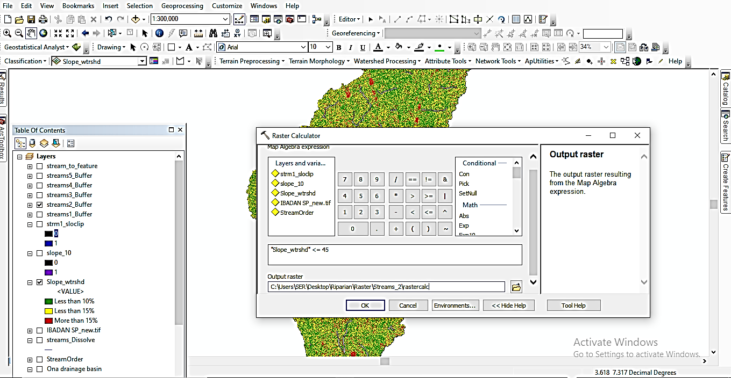

Fig.3.2: The raster calculator in use

**3.6.4** **GIS SPATIAL ANALYSIS TECHNIQUES**

Four major GIS operations were performed to achieve the set objectives of the project. These are Buffering, Dissolve, Merge, Attribute query, and Raster calculator.

**Buffering:** It is a spatial analysis tool known as proximity analysis, generating zones of a given distance around a feature theme. It forms a distance boundary around a point, line or polygon theme by locating its boundaries around a specified distance. In the study, all stream order were buffered according to specific distances as cited by literature (Leopold *et. al.,* 1964 and Tockner 2002). 1st stream order was buffered to a distance of 30m, 2nd stream order was buffered to a distance of 60m, 3rd stream order was buffered to a distance of 90m, 4th order was buffered to a distance of 120m while 5th order was buffered to a distance of 150m, as shown in Table 3.3.

* **Dissolve:** it aggregate features based on the specified attribute. In the study all streams grid codes were dissolved to have a total length of a particular stream.
* **Merge:** It combines multiple input datasets of the same data type into a single, new output dataset. This tool can combine point, line, or polygon feature classes or tables. In the study the merge tool was used to combine all the stream order together to find a total area covered.
* **Select by Attribute**: Arc map provides the ability to select the features of one or more themes using the background information available in the attribute table of the feature or theme. Thus wanted or unwanted theme (s) can be selected to remove or export as a new layer (Fig 3.3). In the study the query by attribute was used to select all land cover that make up the riparian zone excluding water body from the list.

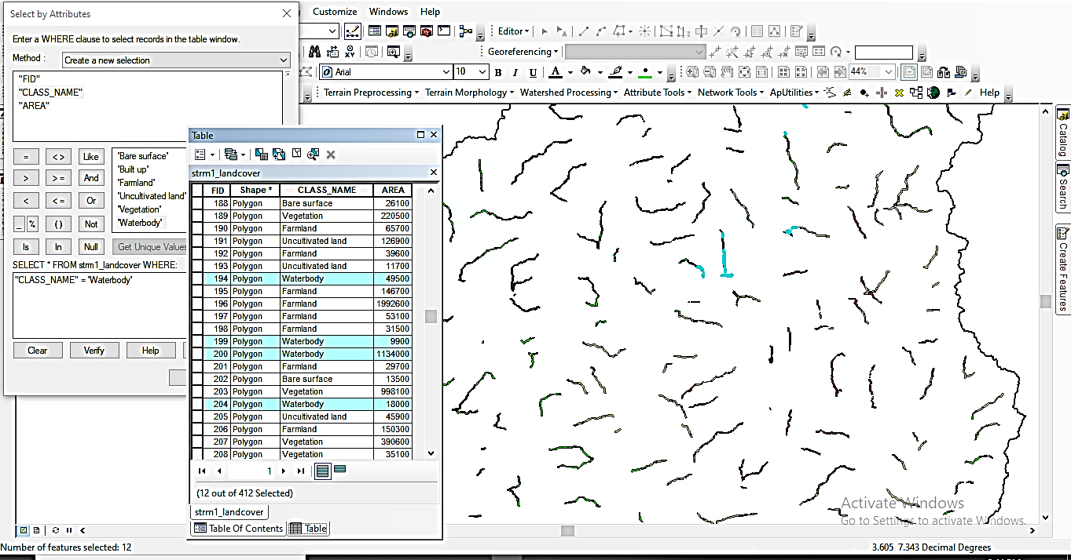

Fig.3.3: The select by attribute in use

**Table 3.3: Estimated riparian width in meters and slope in percent rise**

|  |  |  |
| --- | --- | --- |
| Stream order | Estimated riparian width (m) | Slope Class (%) |
| 1 | 30 | 0-10 |
| 2 | 60 | 11-45 |
| 3 | 90 | 45+ |
| 4 | 120 | 45+ |
| 5 | 150 | 45+ |

Source (Leopold *et. al.,* 1964, Tockner and Stanford 2002)

**3.7 CARTOGRAPHIC MODEL**

Cartographic modeling is the graphical representation of data, analytical procedures and workflow. The figure below show the cartographic mode adopted for this project.

Raster calculator

ALOS PARSAR DEM

Slope

Buffering of stream order

Stream order

Hydrological Analysis

Accuracy Assessment

Image classification

Clipping of riparian zone

Radiometric correction

Landsat Images

Land cover Maps

Merged stream order

Clipped changes in riparian zone

Change detection

Fig.3.4: Cartographic model

**CHAPTER FOUR**

**RESULTS AND DISCUSSION**

**4.0 INTRODUCTION**

A Major advantage of GIS is the ease with which spatial data are being displayed. The dataset after being analyzed are being displayed in easy to understand infographics showing their spatial location. This chapter includes the result of the GIS analysis carried out in the course of this study. This analysis determines the information that can be generated from the various dataset. Hydrological analysis and stream ordering were done to determine the stream order in the Ona drainage basin, this was after the drainage basin has been delineated.

**4.1 ESTIMATION OF RIPARIAN ZONE**

The Arc Hydro extension tools in ArcGIS was used to calculate the drainage basin characteristics of Ona Basin within Ibadan Region. The results of the analysis revealed that Ona River has a dendritic drainage pattern. The analyses further showed that the 1st order has 4,150 streams, 2nd order has 67 streams, 3rd order has 15 streams, and 4th order has 2 streams while the 5th order has 1 stream. Basin slope was calculated, this was to enable the delineation of riparian zone. Slope Identifies the gradient, or rate of maximum change in steepness from each cell of a raster surface. The result revealed slope range of 6-76%. Areas with slope less than 10% made up about 24.7km² of the basin, area between slope ranges 10-15% made up about 29.05km² of the basin while areas with slope range of 15% and above made up about 47.0km² of the basin. These streams were buffered to a specific distance as cited by Leopold *et. al.,* 1964, the 1st order stream was buffered to a distance of 30m, 2nd order stream was buffered to a distance of 60m, 3rd order stream was buffered to a distance of 90m, 4th order was buffered to a distance of 120m and 5th order was buffered to a distance of 150m.

Given the degree of steepness the riparian zone of a stream order can be found, the raster calculator was used to calculate the areas that can be called the riparian zone, as shown on the (Fig 4.3) maps below, 1st order stream have riparian zone in areas where the slope is less than 15%, 2nd order streams have riparian zone where the slope is not more 45%, the third, fourth and fifth order stream can have riparian zone in areas where the riparian zone is more than 45%.

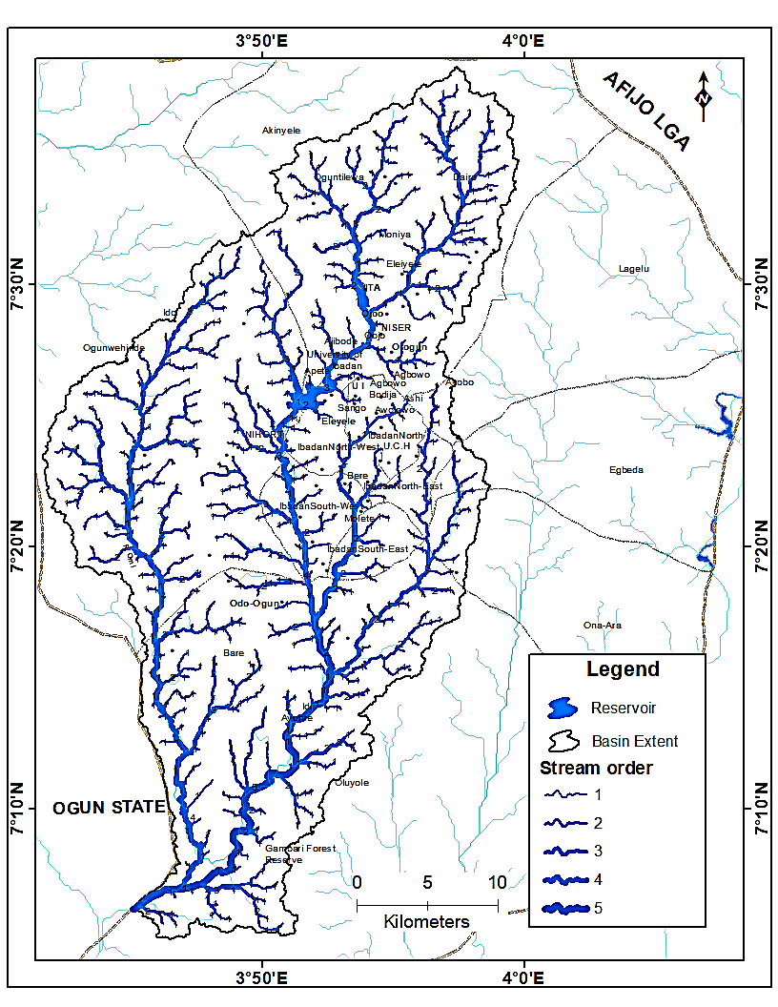

Fig. 4.1: Map showing Stream order in the Ona drainage Basin in Ibadan.

Source: Author’s analysis, 2019

The buffered streams were overlaid on the slope which was processed from the Alos parser DEM, areas that met the specific criteria were given the value of 1 by the raster calculator while areas that do not meet the criteria were given the value of 0. The select by attribute button in the layer’s attribute table was used to select the areas with the value of 1 as the riparian area. This was done for all stream order as shown on the (Fig 4.2) below.

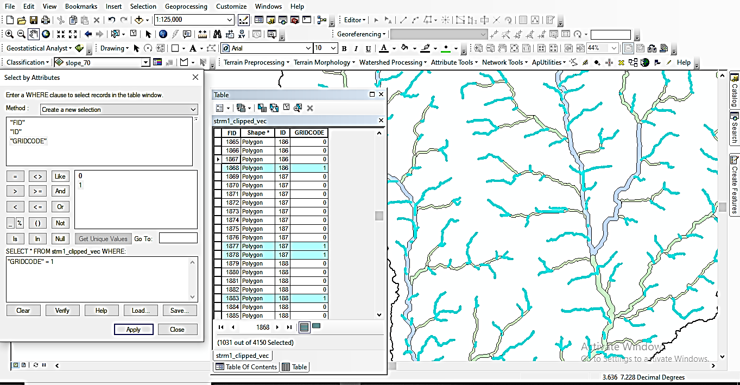

Fig. 4.2: The select by attribute tool in use

Source: Author’s analysis, 2019

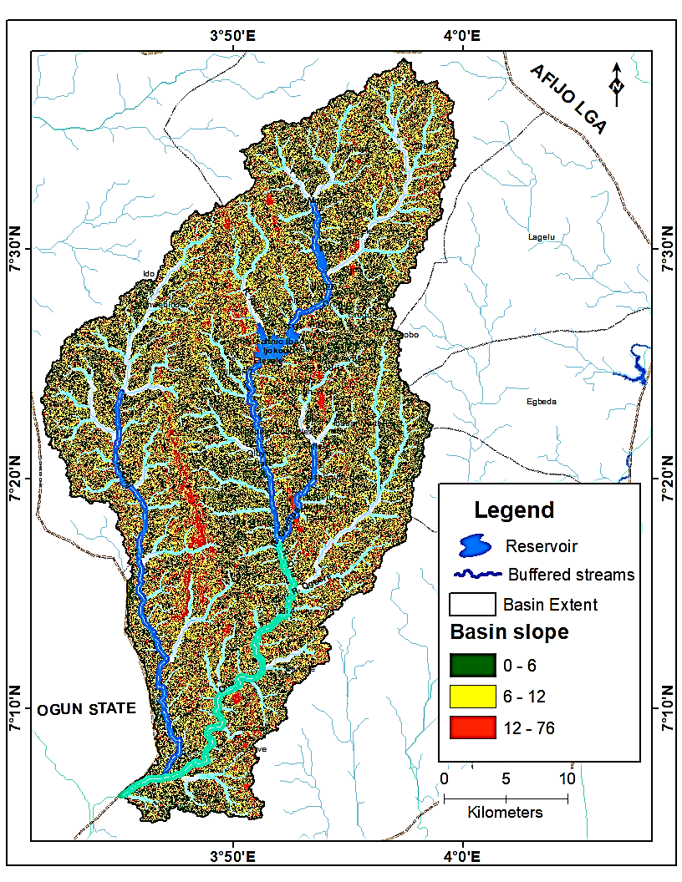

Fig. 4.3: Map showing the slope of Ona drainage basin overlaid by buffered stream order.

Source: Author’s analysis, 2019

The total riparian zone covered by the 1st stream order is 24.713km², the 2nd order streams covered about 29.05km² of riparian zone, the 3rd order steams has 16.978km² riparian zone, the 4th order streams has 20.14km² riparian zone while the 5th order stream has 9.93km² riparian zone. Fig 4.4 shows the extent of each stream order. The total area covered by riparian zone in the Ona drainage basin in Ibadan is estimated to be 100.81km².

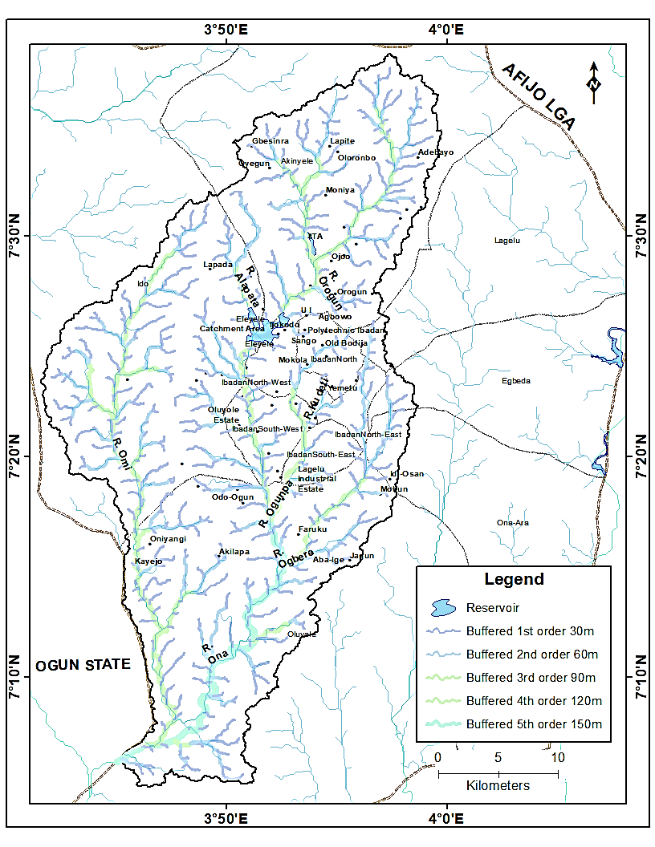

Fig 4.4: Map showing the Extent of riparian zone in Ona drainage basin.

Source: Author’s analysis, 2019

**4.2 LANDCOVER OF RIPARIAN ZONE**

In order to examine the Land cover of the riparian zone the result from the analysis of extent of riparian zone was overlaid on the classified Landsat images (TM 1984, ETM+ 2002 and ETM+2018). The accuracy assessment of the 2018 land use/ land cover image was generated by comparing the classified image with reference data (ground truth point) which was done by generating random points on the classified image and exporting the points to google earth for ground truthing.

**Table 4.1: Confusion matrix for land use / land cover classes**

|  |  |  |  |  |  |  |  |
| --- | --- | --- | --- | --- | --- | --- | --- |
| Class Name | Built up | Light vegetation | Dense vegetation | Agricultural Land | Water body | Peri-Urban | Total |
| Built up | 4 | 0 | 0 | 0 | 0 | 0 | 4 |
| Light vegetation | 1 | 4 | 1 | 0 | 0 | 1 | 7 |
| Dense vegetation | 0 | 0 | 5 | 1 | 0 | 0 | 6 |
| Agricultural land | 0 | 0 | 0 | 5 | 0 | 0 | 5 |
| Water body | 0 | 0 | 0 | 0 | 6 | 0 | 6 |
| Peri-Urban | 1 | 1 | 0 | 0 | 0 | 6 | 6 |
| Total | 6 | 5 | 6 | 6 | 6 | 7 | 30 |
|  |  |  |  |  |  |  |  |

The overall accuracy for land use/land cover classification is 83%.

The images were clipped to the extent of the Ona drainage basin and according to stream order for the different years. In 1984, Tables 4.2(a, b, c, d & e) show that Agricultural activities and Peri-Urban growth were the main human activities that threatened the riparian zone with the highest value among the land use classes.

**Table 4.2a: Total riparian land cover for stream order one in 1984**

|  |  |  |
| --- | --- | --- |
| Class Name | Area (sq. m) | Percentage (%) |
| Peri - Urban | 5825498.87 | 23.66 |
| Built up | 2224477.91 | 9.03 |
| Dense vegetation | 627028.60 | 2.55 |
| Agricultural land | 4721107.23 | 19.17 |
| Light vegetation | 11226387.33 | 45.59 |
| Total | **24624499.93** | **100.00** |

Source: Author’s analysis, 2019

**Table 4.2b: Total riparian land cover for stream order two in 1984**

|  |  |  |
| --- | --- | --- |
| Class Name | Area (sq. m) | Percentage (%) |
| Peri - Urban | 7453494.61 | 25.80 |
| Built up | 2797177.78 | 9.68 |
| Dense vegetation | 480948.50 | 1.66 |
| Agricultural land | 5580392.75 | 19.32 |
| Light vegetation | 12578835.91 | 43.54 |
| Total | **28890849.55** | **100.00** |

Source: Author’s analysis, 2019

**Table 4.2c: Total riparian land cover for stream order three in 1984**

|  |  |  |
| --- | --- | --- |
| Class Name | Area (sq. m) | Percentage (%) |
| Peri - Urban | 3350478.23 | 19.99 |
| Built up | 1179136.51 | 7.03 |
| Dense vegetation | 784181.73 | 4.68 |
| Agricultural land | 2790695.53 | 16.65 |
| Light vegetation | 8660254.85 | 51.66 |
| Total | **16764746.84** | **100.00** |

**Table 4.2d: Total riparian land cover for stream order four in 1984**

|  |  |  |
| --- | --- | --- |
| Class Name | Area (sq. m) | Percentage (%) |
| Peri - Urban | 3350478.23 | 19.99 |
| Built up | 1179136.51 | 7.03 |
| Dense vegetation | 784181.73 | 4.68 |
| Agricultural land | 2790695.53 | 16.65 |
| Light vegetation | 8660254.85 | 51.66 |
| Total | **16764746.84** | **100.00** |

Source: Author’s analysis, 2019

**Table 4.2e: Total riparian land cover for stream order five in 1984**

|  |  |  |
| --- | --- | --- |
| Class Name | Area (sq. m) | Percentage (%) |
| Peri - Urban | 1749907.99 | 17.6 |
| Dense vegetation | 290031.38 | 2.9 |
| Agricultural land | 4088180.42 | 41.2 |
| Light vegetation | 3804378.77 | 38.3 |
| Total | **9932498.57** | **100.0** |

Source: Author’s analysis, 2019

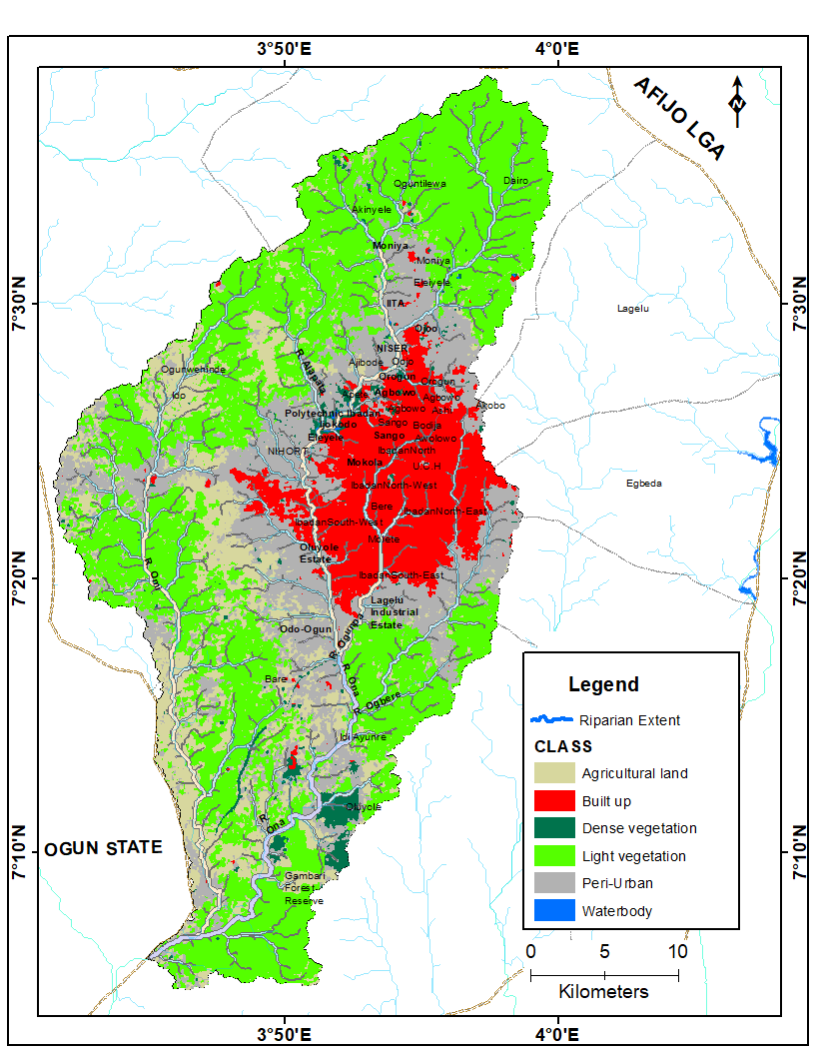 Fig 4.5(a): Land use /land cover of Ona drainage basin for 1984 overlaid with the buffered stream order.

Source: Author’s analysis, 2019

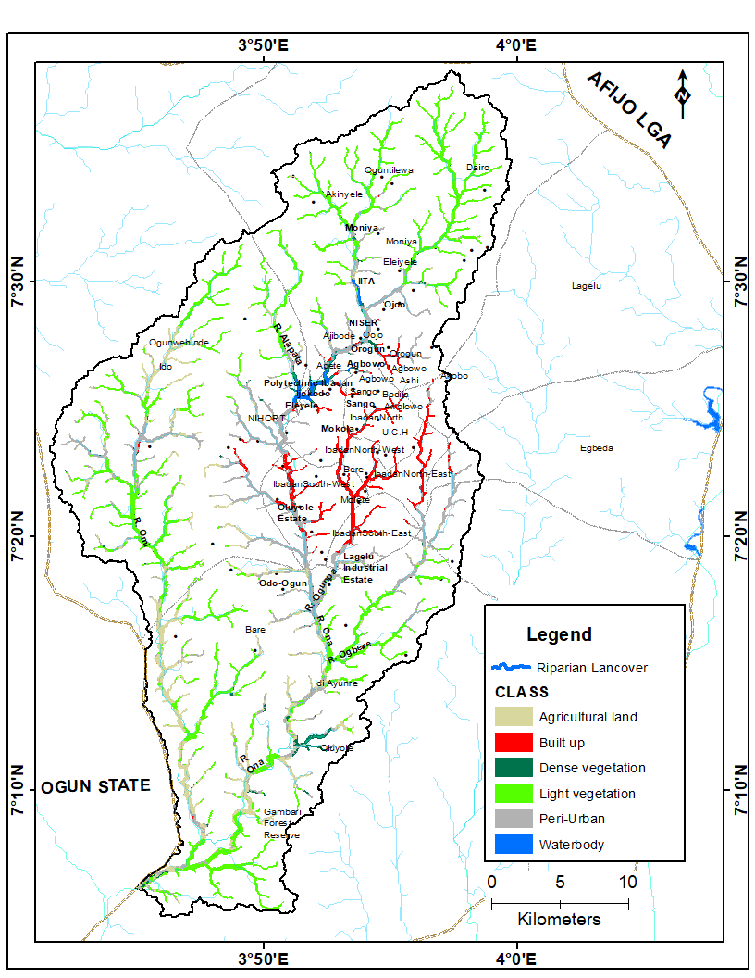

Fig 4.5(b): Map showing the land use /land cover within riparian zone of Ona drainage basin in 1984.

Source: Author’s analysis, 2019

In 2002, Tables 4.3 (a, b, c, d, &e) show that more riparian zone has been converted to built up (Peri – Urban) and Agricultural land, this shows that riparian vegetation is constantly being removed for other land use, especially building of houses and farming, this was followed. This was affirm by the drastic reduction in the vegetation of the riparian zone within this period.

**Table 4.3a: Total riparian land cover for stream order one in 2002**

|  |  |  |
| --- | --- | --- |
| Class Name | Area (sq. m) | Percentage (%) |
| Peri - Urban | 11790130.45 | 47.9 |
| Built up | 1819382.58 | 7.4 |
| Dense vegetation | 1041715.60 | 4.2 |
| Agricultural land | 7694726.46 | 31.2 |
| Light vegetation | 2285964.24 | 9.3 |
| Total | **24631919.33** | **100.0** |

Source: Author’s analysis, 2019

**Table 4.3b: Total riparian land cover for stream order two in 2002**

|  |  |  |
| --- | --- | --- |
| Class Name | Area (sq. m) | Percentage (%) |
| Peri - Urban | 13881660.91 | 48.0 |
| Built up | 2362052.98 | 8.2 |
| Dense vegetation | 1507721.22 | 5.2 |
| Agricultural land | 8598639.40 | 29.7 |
| Light vegetation | 2576962.27 | 8.9 |
| Total | **28927036.77** | **100.0** |

**Table 4.3c: Total riparian land cover for stream order three in 2002**

|  |  |  |
| --- | --- | --- |
| Class Name | Area (sq. m) | Percentage (%) |
| Peri - Urban | 7222403.07 | 43.0 |
| Built up | 1157252.15 | 6.9 |
| Dense vegetation | 1035121.18 | 6.2 |
| Agricultural land | 5762082.77 | 34.3 |
| Light vegetation | 1630393.03 | 9.7 |
| Total | **16807252.20** | **100.0** |

Source: Author’s analysis, 2019

**Table 4.3d: Total riparian land cover for stream order four in 2002**

|  |  |  |
| --- | --- | --- |
| Class Name | Area (sq. m) | Percentage (%) |
| Peri - Urban | 10206569.46 | 52.6 |
| Built up | 1800183.86 | 9.3 |
| Dense vegetation | 1039350.31 | 5.4 |
| Agricultural land | 6199367.97 | 31.9 |
| Light vegetation | 162111.44 | 0.8 |
| Total | **19407583.05** | **100.0** |

Source: Author’s analysis, 2019

**Table 4.3e: Total riparian land cover for stream order five in 2002**

|  |  |  |
| --- | --- | --- |
| Class Name | Area (sq. m) | Percentage (%) |
| Peri - Urban | 3380294.84 | 34.0 |
| Dense vegetation | 1047167.37 | 10.5 |
| Agricultural land | 5386907.56 | 54.2 |
| Light vegetation | 118128.80 | 1.2 |
| Total | **9932498.57** | **100.0** |

Source: Author’s analysis, 2019

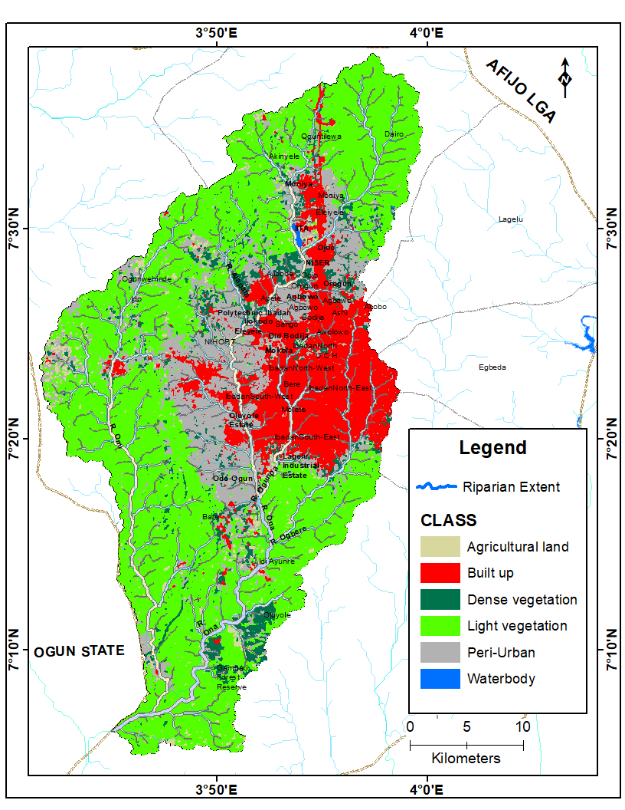

Fig 4.6(a): Land use /land cover of Ona drainage basin for 2002 overlaid with the buffered stream order.

Source: Author’s analysis, 2019

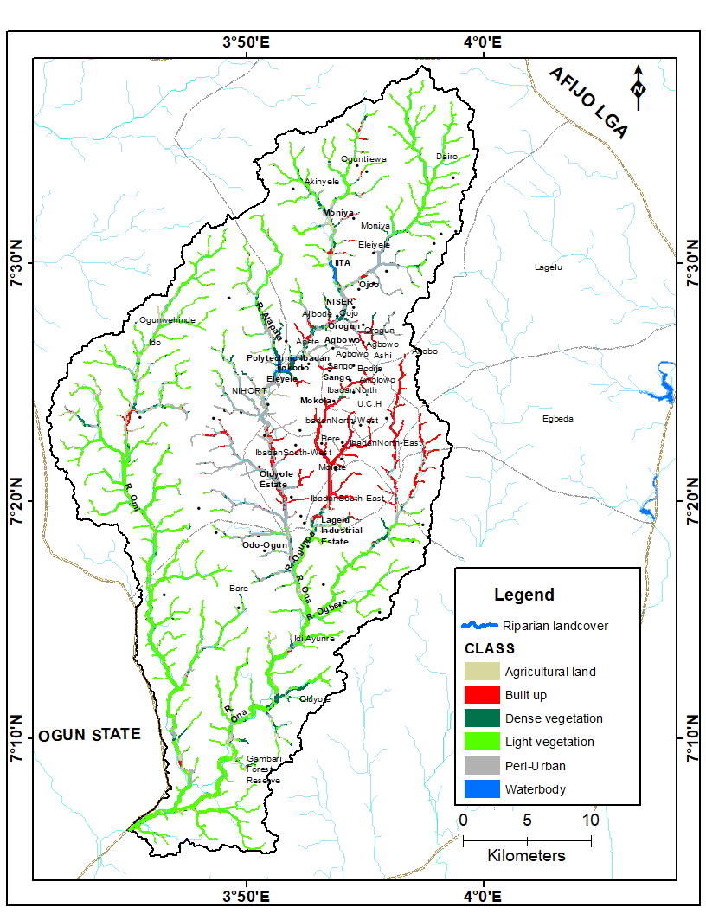

Fig 4.6(b:) Map showing the land use /land cover within riparian zone of Ona drainage basin in 2002.

Source: Author’s analysis, 2019

In 2018, Tables 4.4(a, b, c, d, &e) show that the encroachment on riparian zone by human activities continued as Agricultural land, Peri-Urban and built up (Urban) had the highest percentage of the riparian zone. This shows that the riparian zone is in critical state with drastic reduction in vegetation over the past 16 years.

**Table 4.4a: Total riparian land cover for stream order one in 2018**

|  |  |  |
| --- | --- | --- |
| Class Name | Area (sq. m) | Percentage (%) |
| Peri - Urban | 9602828.33 | 38.9 |
| Built up | 4120620.35 | 16.7 |
| Dense vegetation | 1968881.13 | 8.0 |
| Agricultural land | 3732184.05 | 15.1 |
| Light vegetation | 5247317.07 | 21.3 |
| Total | **24671830.93** | **100.0** |

Source: Author’s analysis, 2019

**Table 4.4b: Total riparian land cover for stream two in 2018**

|  |  |  |
| --- | --- | --- |
| Class Name | Area (sq. m) | Percentage (%) |
| Peri - Urban | 10657898.07 | 36.8 |
| Built up | 5571366.94 | 19.2 |
| Dense vegetation | 2002776.49 | 6.9 |
| Agricultural land | 5488754.12 | 19.0 |
| Light vegetation | 5233735.02 | 18.1 |
| Total | **28954530.63** | **100.0** |

Source: Author’s analysis, 2019

**Table 4.4c: Total riparian land cover for stream order three in 2018**

|  |  |  |
| --- | --- | --- |
| Class Name | Area (sq. m) | Percentage (%) |
| Peri - Urban | 7134553.54 | 42.6 |
| Built up | 2174567.18 | 13.0 |
| Dense vegetation | 1609811.36 | 9.6 |
| Agricultural land | 2725434.44 | 16.3 |
| Light vegetation | 3113233.67 | 18.6 |
| Total | **16757600.19** | **100.0** |

Source: Author’s analysis, 2019

**Table 4.4d: Total riparian land cover for stream order four in 2018**

|  |  |  |
| --- | --- | --- |
| Class Name | Area (sq. m) | Percentage (%) |
| Peri - Urban | 8489173.49 | 43.2 |
| Built up | 3330261.26 | 16.9 |
| Dense vegetation | 1556581.62 | 7.9 |
| Agricultural land | 4292836.01 | 21.8 |
| Light vegetation | 1984347.18 | 10.1 |
| Total | **19653199.55** | **100.0** |

Source: Author’s analysis, 2019

**Table 4.4e: Total riparian land cover for stream order five in 2018**

|  |  |  |
| --- | --- | --- |
| Class Name | Area (sq. m) | Percentage (%) |
| Peri - Urban | 4046398.08 | 40.7 |
| Built up | 22627.31 | 0.2 |
| Dense vegetation | 2851759.33 | 28.7 |
| Agricultural land | 2898005.07 | 29.2 |
| Light vegetation | 113708.77 | 1.1 |
| Total | **9932498.57** | **100.0** |

Source: Author’s analysis, 2019

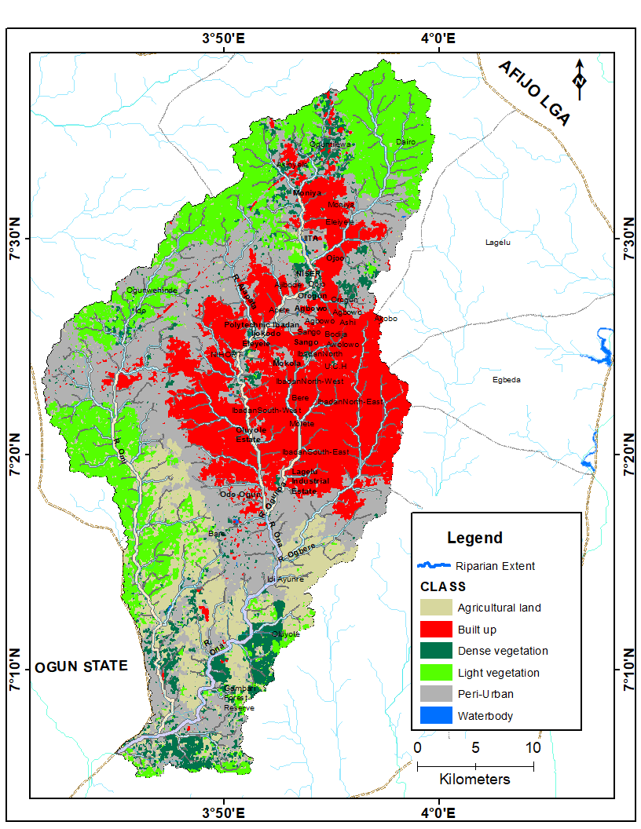

Fig 4.7(a): Map showing land use /land cover within riparian zone of Ona drainage basin in 2018.

Source: Author’s analysis, 2019

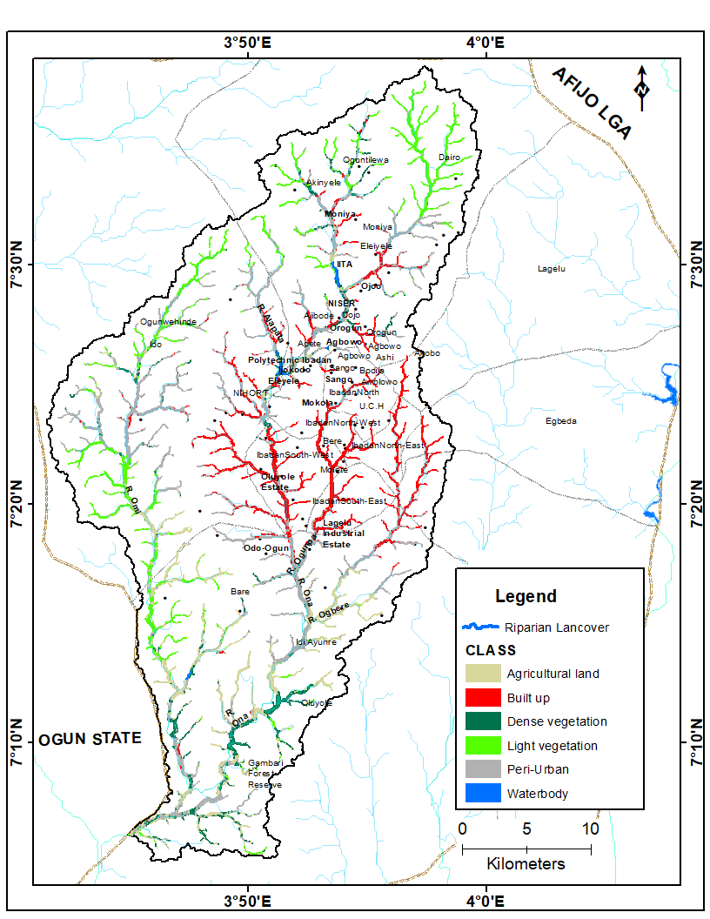

Fig 4.7(b): Map showing land use /land cover within riparian zone of Ona drainage basin in 2018.

Source: Author’s analysis, 2019

**4.3 ANALYSIS OF SPATIAL AND TEMPORAL CHANGES IN LANDSCAPE OF RIPARIAN ZONE.**

To effectively analyze the spatial and temporal changes in the landscape of the riparian zone, the stream orders were merged together using the merge tool in ArcGIS data management toolbox. The 1st, 2nd, 3rd, 4th and 5th streams order were merged into one shapefile to give a total area covered by the riparian zone. This merged stream was overlaid on the result of the classified changed images of 1984 and 2002 and that of 2002 and 2018.

The results as presented by tables 4.4a & 4.4b indicated that more of riparian vegetation were lost to Agricultural land and Peri-urban with the former contributing to about 20% of the change, while the latter covered about 12% of the change in total riparian zone. This constitute the highest conversion rate between 1984 to 2002, it can then be said that farming was the human activities that contributed most to the changes in riparian zone between 1984 to 2002, followed by conversion from vegetation to bare surface, vegetated areas were converted to roads, concrete surfaces, excavated surfaces among others.

**Table 4.5a: Land use/Land cover change in riparian zone 1984-2002**

|  |  |  |
| --- | --- | --- |
| Change between (1984-2002) | Area (sq.) | Percentage (%) |
| Peri - Urban - Built up | 885056.84 | 0.9 |
| Peri - Urban - Dense vegetation | 1463241.28 | 1.5 |
| Peri - Urban – Agricultural land | 2681964.79 | 2.8 |
| Peri - Urban - Light vegetation | 49038.23 | 0.1 |
| Built up - Peri - Urban | 1743547.54 | 1.8 |
| Built up - Dense vegetation | 20100.11 | 0.0 |
| Dense vegetation - Peri - Urban | 1458635.74 | 1.5 |
| Dense vegetation - Built up | 149058.54 | 0.2 |
| Dense vegetation - Agricultural land | 321961.00 | 0.3 |
| Dense vegetation - Water body | 26111.83 | 0.0 |
| Agricultural land - Peri - Urban | 10026121.37 | 10.6 |
| Agricultural land - Built up | 33465.18 | 0.0 |
| Agricultural land - Dense vegetation | 1454773.35 | 1.5 |
| Agricultural land - Light vegetation | 76660.69 | 0.1 |
| Light vegetation - Bare surface | 11209394.24 | 11.8 |
| Light vegetation - Built up | 62207.85 | 0.1 |
| Light vegetation - Dense vegetation | 837444.28 | 0.9 |
| Light vegetation - Agricultural land | 19417758.12 | 20.5 |
| no change - no change | 42652586.16 | 45.0 |
| Water body Peri - Urban | 15461.10 | 0.0 |
| Water body - Dense vegetation | 83101.13 | 0.1 |
| Water body - Agricultural land | 140569.08 | 0.1 |
| Total | **94808258.45** | **100.0** |

Source: Author’s analysis, 2019

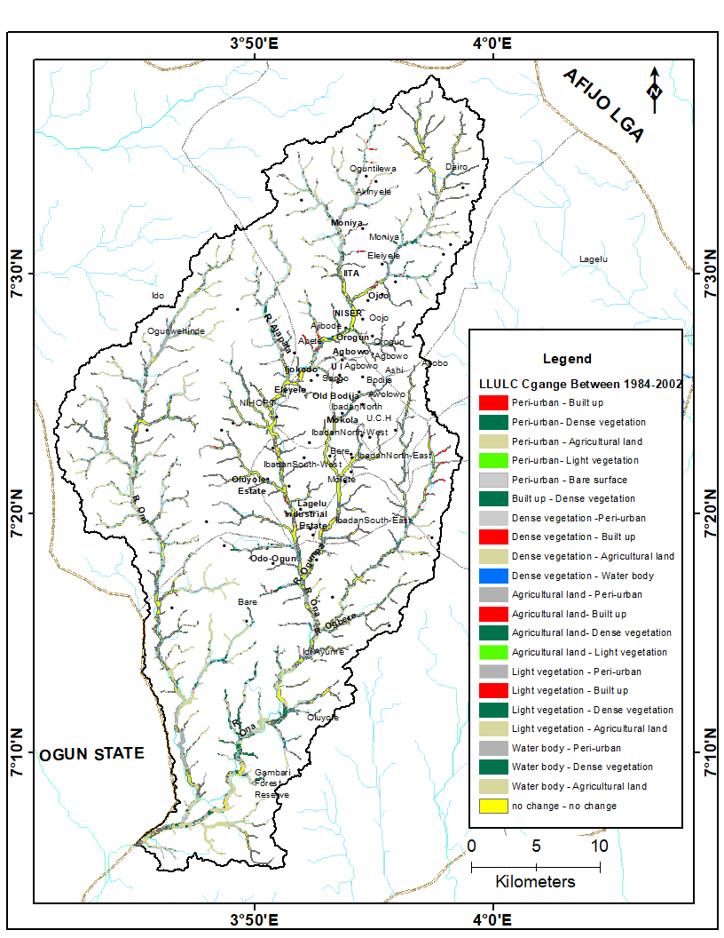 Fig 4.8(a): Map showing Landuse/Landcover change in riparian zone from 1984-2002

Source: Author’s analysis, 2019

The result as presented by table 4.4b indicated that the land use/land cover in the riparian zone from 2002-2018 was dominated by changes from Peri-urban to Peri-urban about 26.5% of the total area covered by riparian area were converted to open surfaces. This was followed by conversion between Agricultural land to Agricultural land which represent about 12% of the total riparian zone, the high rate of conversion of the vegetation in the riparian zone to bare surfaces and farmland indicated the need for restoration and conservation of the riparian zone.

**Table 4.5b: Land use/Land cover change in riparian zone 2002-2018**

|  |  |  |
| --- | --- | --- |
| Changes Between (2002-2018) | Area (sq. m) | Percentage (%) |
| Peri - Urban - Peri - Urban | 25104604.52 | 26.5 |
| Peri - Urban - Built up | 7366299.49 | 7.8 |
| Peri - Urban - Dense vegetation | 4745448.26 | 5.0 |
| Peri - Urban - Agricultural land | 3217793.69 | 3.4 |
| Peri - Urban - Light vegetation | 3273488.28 | 3.5 |
| Peri - Urban - Water body | 32284.87 | 0.0 |
| Built up - Peri - Urban | 243714.26 | 0.3 |
| Built up - Built up | 6720916.82 | 7.1 |
| Built up - Dense vegetation | 35748.06 | 0.0 |
| Built up - Water body | 14738.34 | 0.0 |
| Dense vegetation - Peri - Urban | 2014343.68 | 2.1 |
| Dense vegetation - Built up | 323540.24 | 0.3 |
| Dense vegetation - Dense vegetation | 2010576.07 | 2.1 |
| Dense vegetation - Agricultural land | 579173.23 | 0.6 |
| Dense vegetation - Light vegetation | 111334.33 | 0.1 |
| Dense vegetation - Water body | 77085.72 | 0.1 |
| Agricultural land - Peri - Urban | 9314910.18 | 9.8 |
| Agricultural land - Built up | 138826.31 | 0.1 |
| Agricultural land - Dense vegetation | 2218431.26 | 2.3 |
| Agricultural land - Farm land | 12238031.13 | 12.9 |
| Agricultural land - Light vegetation | 7583174.46 | 8.0 |
| Light vegetation - Peri - Urban | 862139.89 | 0.9 |
| Light vegetation - Dense vegetation | 142660.48 | 0.2 |
| Light vegetation - Agricultural land | 1571406.90 | 1.7 |
| Light vegetation - Light vegetation | 3867231.06 | 4.1 |
| Water body - Dense vegetation | 91717.79 | 0.1 |
| Water body - Agricultural land | 313537.63 | 0.3 |
| Water body - Light vegetation | 2700.00 | 0.0 |
| Water body - Water body | 592401.54 | 0.6 |
| Total | **94808258.50** | **100.0** |

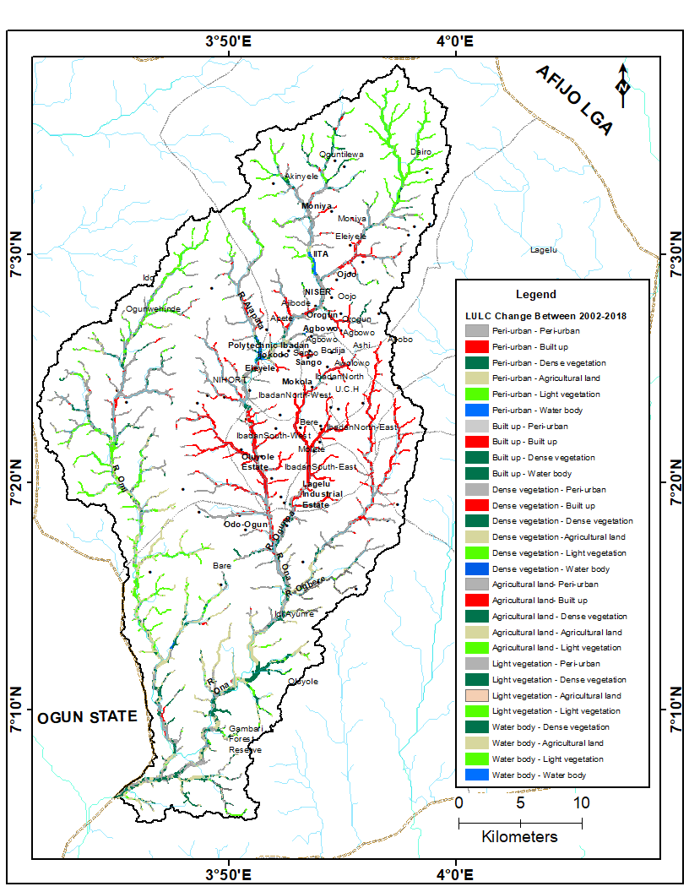

Fig 4.8(b): Map showing Land use/Land cover change in riparian zone from 2002-2018

Source: Author’s analysis, 2019

**4.4 CONTRIBUTION OF SPECIFIC HUMAN ACTIVITIES TO CHANGES WITHIN THE RIPARIAN ZONE.**

Table 4.6 below gives a breakdown of the present state of the Ona Drainage Basin in Ibadan. The total area of the riparian zone was estimated to be 94808258.52 m² or 9.8 km² in 2018, Peri – Urban i.e. recent urban development occupies about 40% of the highest contributor to the changes within the zone, Agricultural land use follows with about 19% of the riparian zone used for different Agricultural purposes. The vegetation of the riparian zone which is one of it most important feature occupies about 15% of the zone, the same for built up, the forested or densely vegetated part of the zone has seriously been depleted by human activities, with only 10% of the zone still densely forested. The implication of this perpetual depletion and encroachment into the riparian zone will result in soil loss due to high surface run off of erosion, many part of the drainage basin will be susceptible to flooding due to the removal of the forested vegetation which is supposed to act as natural breaks for flood water during stream overflow. Detailed analysis of the land cover classes according to stream order is given below.

**4.6 Total Area Covered by Riparian Zone in 2018**

|  |  |  |
| --- | --- | --- |
| Class Name | Area (sq. m) | Percentage (%) |
| Peri - Urban | 37408359.25 | 39.5 |
| Built up | 14598716.64 | 15.4 |
| Dense vegetation | 9350151.52 | 9.9 |
| Agricultural land | 17890288.05 | 18.9 |
| Light vegetation | 14837410.55 | 15.6 |
| Water body | 723332.52 | 0.8 |
| Total | **94808258.52** | **100.0** |

Source: Author’s analysis, 2019

**4.6a First Order Riparian Land Cover in 2018**

|  |  |  |
| --- | --- | --- |
| Class Name | Area (sq. m) | Percentage (%) |
| Peri - Urban | 9602828.33 | 38.9 |
| Built up | 4120620.35 | 16.7 |
| Dense vegetation | 1968881.13 | 8.0 |
| Agricultural land | 3732184.05 | 15.1 |
| Light vegetation | 5247317.07 | 21.3 |
| Total | 24671830.93 | 100.0 |

Source: Author’s analysis, 2019

**4.6b** **Second Order Riparian Land Cover in 2018**

|  |  |  |
| --- | --- | --- |
| Class Name | Area (sq. m) | Percentage (%) |
| Peri - Urban | 10657898.07 | 36.8 |
| Built up | 5571366.94 | 19.2 |
| Dense vegetation | 2002776.49 | 6.9 |
| Agricultural land | 5488754.12 | 19.0 |
| Light vegetation | 5233735.02 | 18.1 |
| Total | **28954530.63** | **100.0** |

Source: Author’s analysis, 2019

**4.6c Third Order Riparian Land Cover in 2018**

|  |  |  |
| --- | --- | --- |
| Class Name | Area (sq. m) | Percentage (%) |
| Peri - Urban | 7134553.54 | 42.6 |
| Built up | 2174567.18 | 13.0 |
| Dense vegetation | 1609811.36 | 9.6 |
| Agricultural land | 2725434.44 | 16.3 |
| Light vegetation | 3113233.67 | 18.6 |
| Total | **16757600.19** | **100.0** |

**4.6d Fourth order riparian land cover in 2018**

|  |  |  |
| --- | --- | --- |
| Class Name | Area (sq m) | Percentage (%) |
| Peri - Urban | 8489173.49 | 43.2 |
| Built up | 3330261.26 | 16.9 |
| Dense vegetation | 1556581.62 | 7.9 |
| Agricultural land | 4292836.01 | 21.8 |
| Light vegetation | 1984347.18 | 10.1 |
| Total | **19653199.55** | **100.0** |

Source: Author’s analysis, 2019

**4.6e** **fifth order riparian land cover in 2018**

|  |  |  |
| --- | --- | --- |
| Class Name | Area (sq. m) | Percentage (%) |
| Peri - Urban | 4046398.08 | 40.7 |
| Built up | 22627.31 | 0.2 |
| Dense vegetation | 2851759.33 | 28.7 |
| Agricultural land | 2898005.07 | 29.2 |
| Light vegetation | 113708.77 | 1.1 |
| Total | **9932498.57** | **100.0** |

Source: Author’s analysis, 2019

**CHAPTER FIVE**

**SUMMARY, CONCLUSION AND RECOMMENDATION**

**5.0 CONCLUSION**

This study has examined the impact of Human activities on the Ona river drainage basin and found out that indeed human activities is the highest contributor to the changes that have taken place in the riparian zone in 34 years, of all the human activities examined to cause changes in the riparian zone, Urban development as occasioned by the growth of the Ibadan city and various Agricultural land use like uncontrolled farming were the largest contributors to the changes that occur in the riparian zone. This findings goes a long way to indicate that the level of awareness of both the citizenry and the policy makers on the ecosystem services the riparian zone provides is extremely low, as these results have shown that the riparian zone is use for farming all year round as no conservation practice has been implemented by the government and the decision makers to preserve this sensitive ecosystem region. The changes that was observed from 2002 to 2018 indicated that built up is fast encroaching into the riparian zone of the Ona drainage basin in Ibadan and it must be checked on time to avert serious environment hazard this might cause.

The study has also shown that GIS is an effective tool in mapping the riparian ecosystem extent for protection and conservation practice.

To obtain the many benefits that a riparian corridor can provide, certain minimum principles must be adhered to: as cited by (Hausner *et. al*., 2018)

• Riparian corridors should extend at least 75 feet from the edge of the stream to perform properly. The 75 feet should include several distinct zones that perform specific functions. Ideally, the first zone should consist of undisturbed forest to provide food and shade for the stream. The second zone should consist of managed grasses and forest that allows for infiltration of runoff, filtration of sediment and nutrients, and nutrient uptake by plants. Finally, flow into the buffer should be transformed from concentrated flow into sheet flow to maximize ground contact with the runoff.

• Development within the riparian corridor should be limited only to structural facilities that are necessary for public health and safety. Agricultural activities would be permitted within the outer zone of the riparian corridor provided they were conducted in conformance with recognized soil conservation practices. When construction activities occur within the riparian corridor, such as stream crossings, specific mitigation measures should be taken.

• The riparian corridor should be uninterrupted. This will help reduce concentrated flow from entering the stream and “shortcircuiting” the filtration and infiltration benefits of riparian corridors. Uninterrupted corridors also provide continuous habitat for the passage of wildlife.

• Recreation within the riparian corridor should be balanced with the effect it may have upon existing features. For example, physical invasion of a riparian corridor maybe limited when it contains plant or animal species of concern or steep slopes or significantly impacts adjacent landowners.

**5.1 RECOMMENDATIONS**

Based on the findings of this study, it is therefore recommended that:

* In order to reap the benefit of riparian zone, it is essential to retain the zone in a vegetated state, preferably as forests. The GIS technique used in this study have proved to be effective and efficient to map accurately the areas that will be retained. This can be used by the decision makers to obtain similar result for riparian zone protection and conservation in the Ona river drainage basin.
* The GIS techniques and analysis used in this study also gives an overview of changes in the riparian zone as mostly occasioned by human activities, this will give the decision makers an idea of what activity to control to easily start the restoration and preservation of the riparian zone ecosystems in the Ona River’s drainage basin.

**References**

Abood, S.A., Maclean, A.L., Mason, L.A., 2012. *Modeling riparian zones utilizing DEMS and flood height data. Photogrammetric Engineering and Remote Sensing* 78, 259-269.

Alaibakhsh, M., Emelyanova, I., Barron, O., Sims, N., Khiadani, M., Mohyeddin, A., 2016. *Delineation of riparian vegetation from Landsat multi-temporal imagery using PCA. Hydrological Processes* 31, 800-810.

Agbola, B. S., Ajayi, O., Taiwo, O. J., & Wahab, B. W. 2012. *The August 2011 Flood in Ibadan. Nigeria : Anthropogenic Causes and Consequences*. *3*(August 2011), 207–217. <https://doi.org/10.1007/s13753-012-0021-3>

Ahmad Jailani, Nobukazu Nakagoshi & Ab Latif Ibrahim, 2004. *Riparian land-use and land cover Change analysis using GIS in Pinang river watershed, Malaysia.*

Areola,O, M.O. Filani, F.O. Akintola & C.O. Ikporukpo. 1994. *The Spatial growth of Ibadan City and its impact on rural hinterland.*

Aquifers, S., & Amanambu, A. C. (2016). *Geogenic Contamination : Hydrogeochemical processes and relationships in Geogenic Contamination : Hydrogeochemical processes and relationships in Shallow Aquifers of Ibadan , South-West Nigeria*. (December 2015). https://doi.org/10.1515/bgeo-2015-0011

Apan, A. A., Raine, S. R., & Paterson, M. S. (2002). *Mapping And Analysis of Changes in the Riparian Landscape Structure of the Mapping and Analysis of Changes in the Riparian Landscape Structure of the Lockyer Valley Catchment , Queensland , Australia*. *2046*(March). https://doi.org/10.1016/S0169-2046(01)00246-8.

Baker, M. E., Wiley, M. J., & Seelbach, P. W. (2002). Parameter Input , the Resulting Information Is. *Journal Of The American Water Resources Association*, *37*(6).

Chambers, J.C. & Miller, J.R. (Eds). (2004*). Great basin riparian ecosystem, ecology, management and restoration*. Washington D.C: Society for ecological restoration international.

Clerici, N., Weissteiner, C.J., Paracchini, M.L., Boschetti, L., Baraldi, A., Strobl, P., 2013. *Pan-European distribution modelling of stream riparian zones based on multi-source Earth Observation data. Ecological Indicators* 24, 211–223 https://doi.org/10.1016/j.ecolind.2012.06.002.

County, M., Ellis, T. J., Matthews, J. R., & Damsker, R. S. *Guidebook for Riparian*

*Corridor Conservation*.

Cosandey, A-C, C. Guenat, M. Bouzelboudjen, V. Maitre, and R. Bovier. 2003. *The modeling of Soil-process functional units based on three-dimensional soil horizon cartography, with an example of denitrification in a riparian zone. Geoderma 112:111- 129.*

Cummins, K. W. (2019). *An Ecosystem Perspective of Riparian Zones Focus on links between*

*land and water*. *41*(8), 540–551.

Daniel Arizpe, Ana Mendes, and João. E. Rabaça 2008. *SUSTAINABLE RIPARIAN ZONES A Management Guide Edited.*

Egbinola,Amanambu,&Taiwo 2016. *Impact of Farming on Riparian Vegetation Along Ona*

*and Orogun Rivers, Ibadan , Oyo State , Nigeria Impacto da Agricultura na Vegetação Ciliar dos Rios Ona e Orogun em Ibadan , Estado de Oyo ( Nigéria )*. (August 2015).

Egunjobi, L (1986) *Human Element in Urban Planning and Development: Ibadan. In:*

*Habitat International.*

Emre Akturk (2013). *RAPID RIPARIAN BUFFER WIDTH AND QUALITY ANALYSIS USING LIDAR IN* SOUTH CAROLINA.

FORMECU 1998: *The assessment of vegetation and land-use changes in Nigeria between*

1976/78 and 1993/95.

Goetz, S. J. (2006). *REMOTE SENSING OF RIPARIAN BUFFERS : PAST PROGRESS AND*

*FUTURE PROSPECTS 1*. *0296*(04205), 133–143.

Gregory, S. V, Swanson, F. J., Mckee, W. A., Kenneth, W., Gregory, S. V, Swanson, F. J.Cummins, K. W. (2019). *An Ecosystem Perspective of Riparian Zones Focus on links between land and water*. *41*(8), 540–551.

Hausner, M. B., Huntington, J. L., Nash, C., Morton, C., McEvoy, D. J., Pilliod, D. S., … Grant, G. (2018). Assessing the effectiveness of riparian restoration projects using Landsat and precipitation data from the cloud-computing application ClimateEngine.org. *Ecological Engineering*, *120*(February), 432–440. https://doi.org/10.1016/j.ecoleng.2018.06.024.

Hyatt, T.L., T.Z. Waldo, and T.J. Beechie. 2004. *A watershed scale assessment of riparian forests, with implications for restoration. Restoration Ecology 12(2):175-183.*

Ilhardt, B. L., E. S. Verry, and B. J. Palik. 2000. *Defining riparian areas. Pg. 29.*

Johansen, K., Coops, N. C., Gergel, S. E., & Stange, Y. (2007). *Application of high spatial resolution satellite imagery for riparian and forest ecosystem classification*. *110*, 29–44. https://doi.org/10.1016/j.rse.2007.02.014.

Jontos, R., 2004. Vegetative buffers for water quality protection*: An introduction and guidance Document. Connecticut Association of Wetland Scientists White Paper on Vegetative Buffers.* Draft version 1.0.22.

Klemas, V., 2014. Remote sensing of riparian and wetland buffers: *An overview. Journal of*

*Coastal Research* 30, 869-880.

Karen, M.M. & Karen, A.S. (1998). *Riparian ecosystem creation and restoration: Functions,*

*fish and wildlife habitat.* U.S Fish and Wildlife Service Biological Report, 89(20), 1–59.

Lawal, M. S. (2016). *Threatened Riparian Habitats in Selected River Banks in Ogun State,*

*Nigeria*. (April). <https://doi.org/10.13140/RG.2.1.3589.9283>.

Leopold L.B, Wolman M.G Miller JP. 1964. *Fluvial Process in Geomorphology. Dover*

*publisher, New York.*

Lowrance, R. R., R. Leonard, and J. Sheridan. 1985. *Managing riparian ecosystems to control Nonpoint pollution. J. Soil Water Conserv. 40:87–91.*

Miller, J.R., T.T. Schulz, N.T. Hobbs, K.R. Wilson, D.L. Schrupp, and W.L. Baker. 1995.

*Changes in the landscape structure of a southeastern Wyoming riparian zone following shifts in stream dynamics. Biological Conservation* (72)371-379.

Naiman, R.J., Decamps, H. & McClain, M.E. (2005). *Riparian ecology, conservation, and*

*management of streamside communities*. Amsterdam: Elsevier Academic Press

National Research Council (NRC). 1995. *Wetlands: characteristics and boundaries.*

*Washington, DC: National Academy Press.*

National Research Council, U.S. (2002). *Riparian areas, functions and strategies for*

*management.* Washington D.C.: The National Academies Press.

Narumalani, S., Y. Zhou, and J.R. Jensen. 1997. *Application of remote sensing and geographic Information systems to the delineation and analysis of riparian buffer zones. Aquatic Botany* 58:393-409.

Odadal, O.E., Olago, D.O., Bugenyi, F., Kulindwa, K., Karimumuryango, J., West, K., Ntiba, M., Wandiga, S., Aloo-Obudho, P. & Achola, P. (2003*). Environmental assessment of the east* *African rift valley lakes, Overview article. Aquatic Science, 65*, 254–271.

Orewole, M. O., Alaigba, D. B., & Oviasu, O. U. (n.d.). *Riparian Corridors Encroachment and Flood Risk Assessment in Ile-Ife : A GIS Perspective*. 1–16.

Onibokun, A. and Faniran, A. (1995) *Urbanization and Urban Problems in Nigeria In: Urban Research in Nigeria. http://doi.org/10.4000/books.ifra.544.*

Rosenblatt, A.E., A.J. Gold, M.H. Stolt, P.M. Groffman, and D.Q. Kellogg. 2001. *Identifying*

*Riparian sinks for watershed nitrate using soil surveys. J. Environ. Qual. 30:1596-1604*.

*Riparian_land-use_and_land_cover_change.pdf*. (n.d.).

Riparian, C., & Joint, H. (2006). *Comparison of Methods to Map California Riparian Areas*.

Stanford, J. A. and J. V. Ward. 1993. *An ecosystem perspective of alluvial rivers: connectivity and the hyporheic corridor. J. N. Am. Benthol. Soc. 12(1):48–60.*

*The national academies press*. Riparian Areas (2002): *Functions and Strategies for Management*. https://doi.org/10.17226/10327.

Tockner K, Standford J.A. 2002. *Riverine Flood Plains: Present State and Future Trend in*

*Hydro-biologia 6661121-133.*

United States Agency for International Development (USAID). (2008). *Sustainable livelihoodsand water management in shared river basins: Lower Songkram Basin, Thailand*. CaseStudy. From http://www.usaid.gov/locations/asia/countries/rdma/.

Watson, A.J. & Basher, L.R. (2006). Stream bank erosion: *A review of processes of bank failure measurement and assessment techniques and modelling approaches*. Montueka Integrated Catchment Management Programme. Land Care ICM Report No. 2006-2006/01, 32.

Wenger, S., 1999. *A review of the scientific literature on riparian buffer width, extent and*

*Vegetation. Institute of Ecology,* University of Georgia. Athens, GA, USA.

Woodward, B. D., Evangelista, P. H., Young, N. E., Vorster, A. G., West, A. M., Carroll, S.

L.Jarnevich, C. (2018). *CO-RIP : A Riparian Vegetation and Corridor Extent Dataset for Colorado River Basin Streams and Rivers*. https://doi.org/10.3390/ijgi7100397.

Zhao, S., J. Fang, W. Ji, Z. Tang. 2003. *Lake restoration from impoldering: impact of land*

*conversion on riparian landscape in Honghu Lake area, Central Yangtze. Agriculture, Ecosystems, and Environment 95:111-118*.

**APPENDIX**

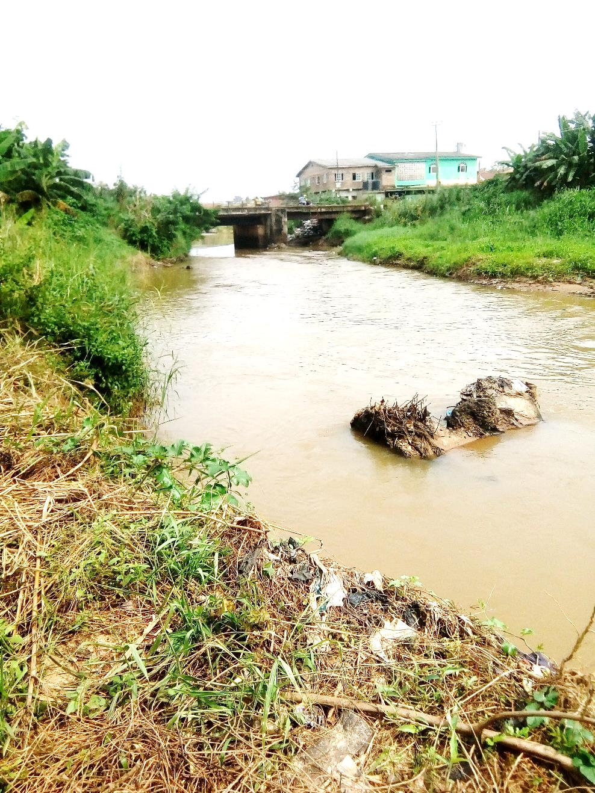

Cross section of Ona riparian zone in Apata

Source: Author’s field work 2019

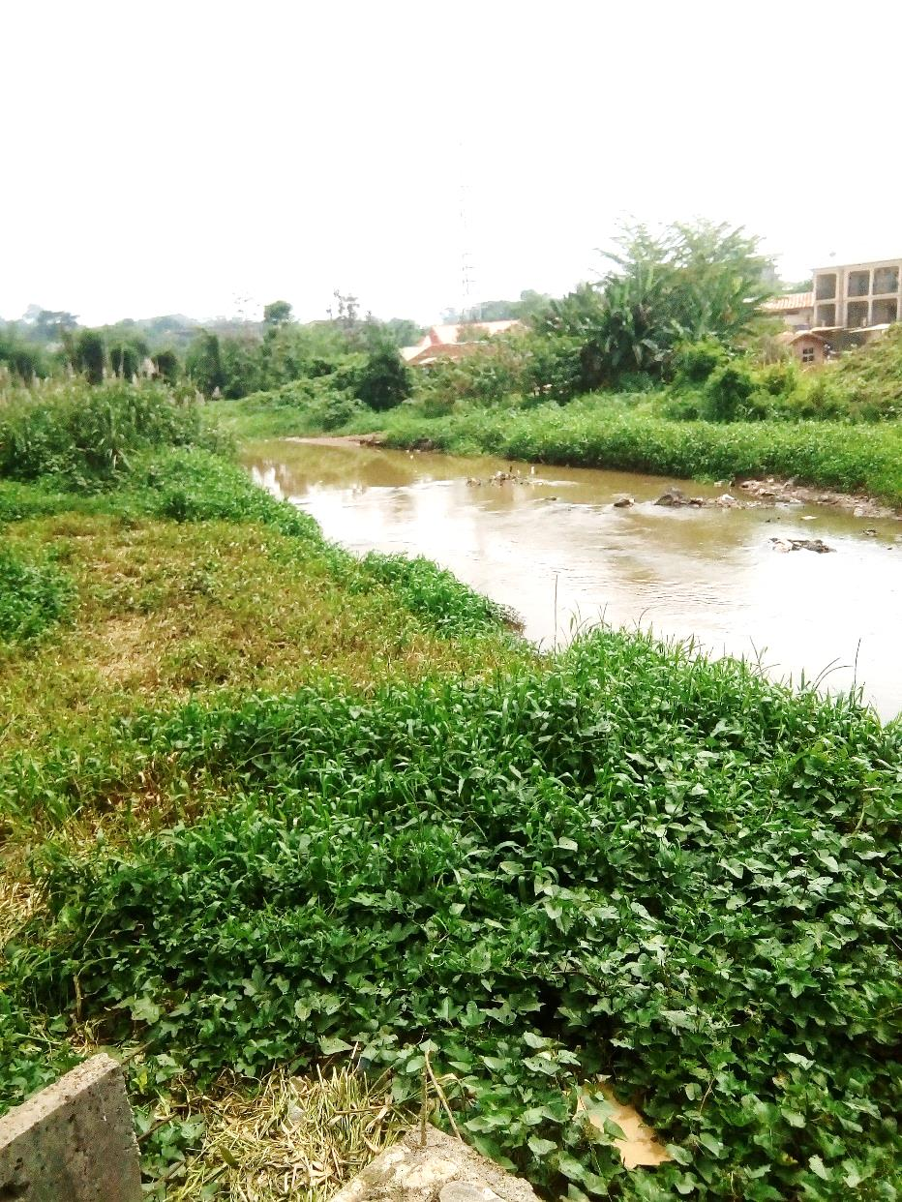

Cross section of Ona riparian zone in Apete

Source: Author’s field work 2019

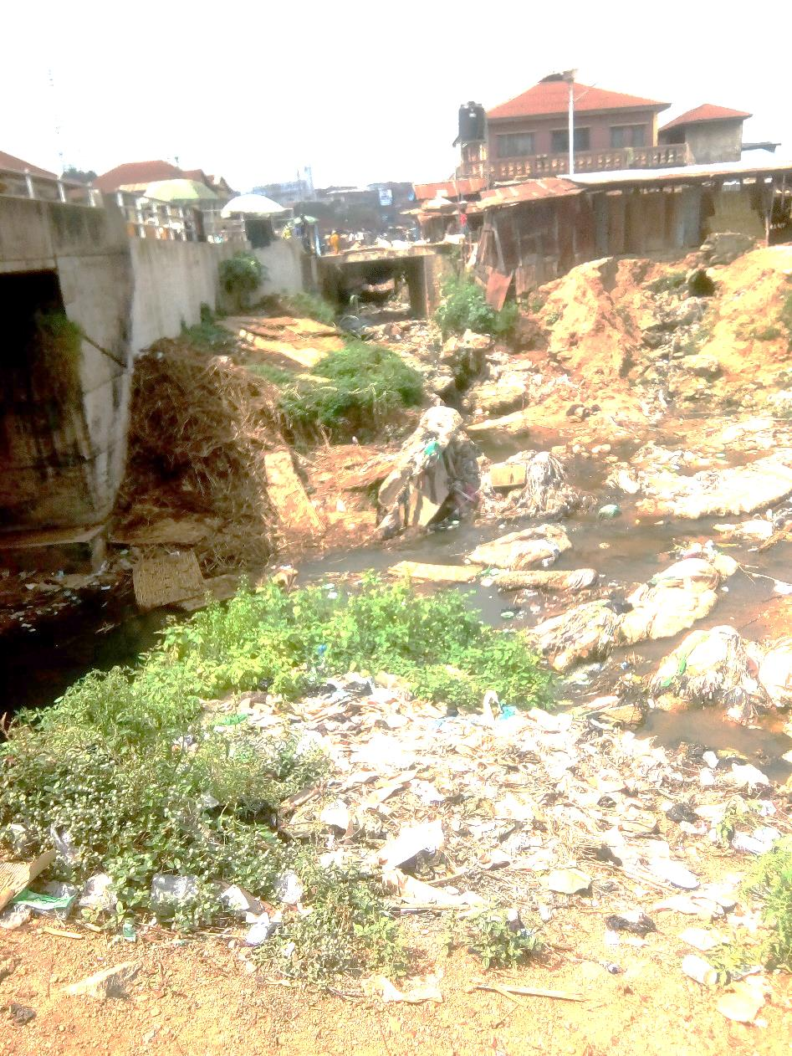

Cross section of River Kudeti’s riparian zone in Bere

Source: Author’s field work 2019